Management Control System

Software Training Materials

**Table of Contents**

1. INTRODUCTION OF MANAGEMENT CONTROL SYSTEM 5

How to Log in the MCS 6

2. FINANCE & ACCOUNTS WING 6

3.MIS PAYROLL MANAGEMENT (SUB MODULE) 8

4.MIS PAYROLL MANAGEMENT MENU OVERVIEW 9

4.1: HR Menu Overview 10

4.1.1.1: Employees (HR) View of Employees details 10

4.1.1.2: Employees (HR) View of Employee (Personal) Data 11

4.1.1.2.1: Employees (HR) Employee (Personal) Data Print 12

4.1.1.3: Employees (HR) View of Employee (Others) Data 12

4.1.1.3.1: Employees (HR) Employee (Others) Data Print 13

4.1.1.4: Employees (HR) View of Employee (Increment) Data 13

4.1.1.4.1: Employees (HR) Employee (Increment) Data Print 14

4.1.1.5: Employees (HR) View of Employee (Training) Data 15

4.1.1.5.1: Employees (HR) Employee (Training) Data Print 16

4.1.1.6: Employees (HR) Search 16

4.1.2.1: Others (HR) Add Others Info input field 17

4.1.2.2: Others (HR) View of Details 18

4.1.2.3: Others (HR) View of Single Details 18

4.1.2.3.1: Others (HR) View of Single Details Print 19

4.1.2.4: Others (HR) Edit 20

4.1.2.5: Others (HR) Delete 20

4.1.2.6: Others (HR) Search 21

4.1.3.1: Increments (HR) Add New Increment input field 22

4.1.3.2: Increments (HR) View of details 22

4.1.3.3: Increments (HR) Edit 23

4.1.3.4: Increments (HR) Delete 23

4.1.3.5: Increments (HR) Search 24

4.2: Allowance Menu Overview 24

4.2.1.1: (Allowance) Entering allowance page input field 24

4.2.1.2: (Allowance) Adding & updating allowance input field 25

4.3: Deduction Menu Overview 26

4.3.1.1: (Deduction) Entering the Deduction page input field 26

4.3.1.2: (Deduction) Adding & updating the deduction input field 27

4.4: Loan Menu Overview 28

4.4.1.1: (Loan) Add Loan input field 28

4.4.1.2: (Loan) View of details 28

4.4.1.3: (Loan) View of single employee details info 29

4.4.1.4: (Loan) Add Loan types input field 30

4.4.1.5: (Loan)View of Add Loan types Details 30

4.4.1.6: (Loan) Add Loan types Details Edit 31

4.4.1.7: (Loan) Search 32

4.5: Salary Menu Overview 32

4.5.1.1: Salary Process (Salary) Month wise salary process input field 33

4.5.2.1: Salary Statement (Salary) Month and Grade wise salary input field 33

4.5.2.2: Salary Statement (Salary) Month wise salary report 34

4.5.2.3: Salary Statement (Salary) Month wise salary report (Single Employee Details) 35

4.5.2.4: Salary Statement (Salary) Month wise salary report (Month wise salary details) 36

4.5.2.5: Salary Statement (Salary) Month wise salary report (Month wise salary details) Print 36

5.CPF MANAGEMENT (SUB MODULE) 37

6. CPF MANAGEMENT MENU OVERVIEW 38

6.1: Opening Balance Menu Overview 39

6.1.1.1: Create (Opening Balance) Accounts Opening Balance Entry Form 39

6.1.2.1: Manage (Opening Balance) View of Details 40

6.1.2.2: Manage (Opening Balance) Update 41

6.1.2.3: Manage (Opening Balance) Delete 41

6.1.2.4: Manage (Opening Balance) Search 42

6.1.3.1: Report (Opening Balance) incomplete(under processing…..) 43

6.2: Sub Opening Balance Menu Overview 43

6.2.1.1: Create (Sub Opening Balance) Accounts Sub Opening Balance Entry Form 43

6.2.2.1: Manage (Sub Opening Balance) View of details sub opening balance 44

6.2.2.2: Manage (Sub Opening Balance) View of details sub opening balance 45

6.2.2.3: Manage (Sub Opening Balance) Delete 45

6.2.2.4: Manage (Sub Opening Balance) Search 46

6.2.3.1: Report (Sub Opening Balance) incomplete(under processing…..) 47

7.FDR MANAGEMENT (SUB MODULE) 47

8.FDR MANAGEMENT MENU OVERVIEW 48

8.1: Settings Menu Overview 49

8.1.1.1: Bank (Settings) Add Bank Entry Form 49

8.1.1.2: Bank (Settings) View details of bank 50

8.1.1.3: Bank (Settings) Update bank type info 50

8.1.1.4: Bank (Settings) Update branch type info 51

8.1.1.5: Bank (Settings) Search 52

8.2: FDR Create Menu Overview 52

8.2.1.1: (FDR Create) input field 53

8.3: BBA FDR Menu Overview 53

8.3.1.1: (BBA FDR) View of BBA FDR Information 53

8.3.1.2: (BBA FDR) View of Single Details 54

8.3.1.3: (BBA FDR) Update input form 55

8.3.1.4: (BBA FDR) Search 56

8.4: Depreciation FDR Menu Overview 56

8.4.1.1: (Depreciation FDR) View of Depreciation FDR Information 56

8.4.1.2: (Depreciation FDR) View of Single Details 57

8.4.1.3: (Depreciation FDR) Update input form 58

8.4.1.4: (Depreciation FDR) Search 59

8.5: Kallyan Trust Menu Overview (Not working ,under processing……) 59

8.6: Pension Fund Menu Overview (Not working ,under processing……) 59

8.7: Report Menu Overview 59

8.7.1.1: (Report) FDR Report generator input field 60

# 1. INTRODUCTION OF MANAGEMENT CONTROL SYSTEM

……….

….

…….

…….

…….

Link for MCS is <http://192.168.3.7:3000/> which is accessible within BBA’s local network . After search will open a login page. Which is like –

### How to Log in the MCS

Figure 1: Log in Page

**Steps to Log in MCS**

1. User will input his Username
2. User will input his Password
3. Click Log In Button

If the username & password are correct, users will get access to the system.

# 2. FINANCE & ACCOUNTS WING

For Finance & Accounts module –

**Steps to Enter in Finance & Accounts**

1. After login will show this dashboard of MCS.

2. Click on the Finance & Accounts.

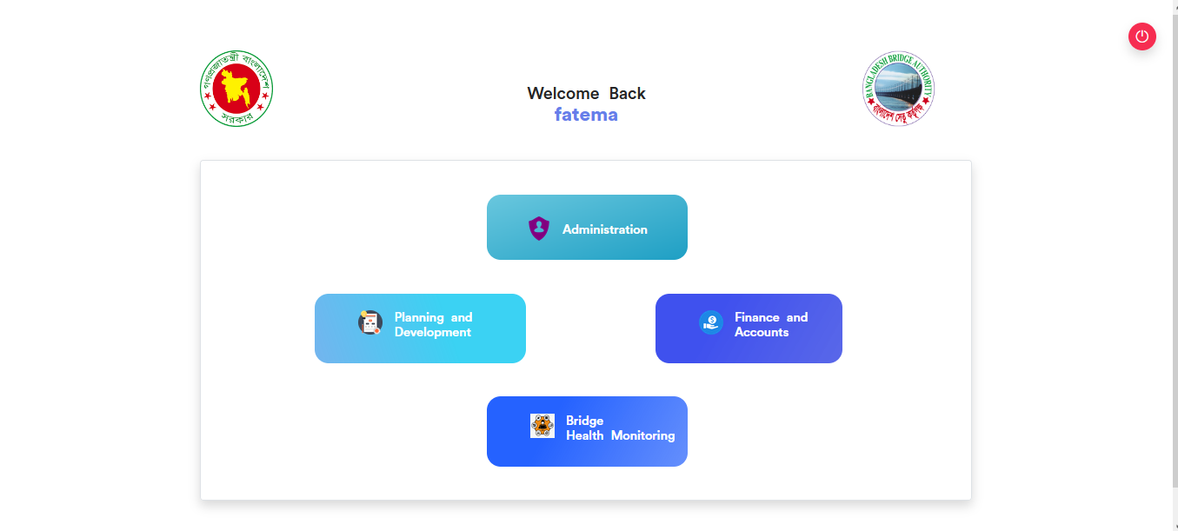

Figure 2.1: Dashboard of MCS

After entering into Finance & Accounts then there will show another dashboard with another four (4) Submodules. Such as-

1.Accounts & Budget Management

2.MIS Payroll Management

3.FDR Management

4.CPF Management

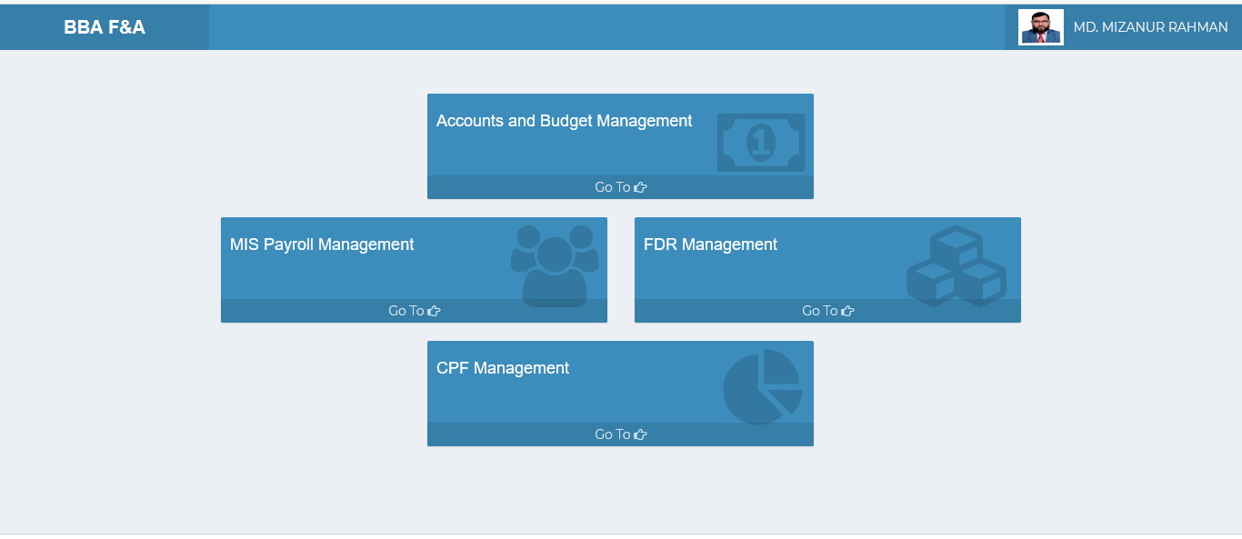

Figure 2.2: Dashboard of Finance & accounts Module.

**Overview of Finance & Accounts Sub Modules**

# 3.MIS PAYROLL MANAGEMENT (SUB MODULE)

After clicking into MIS Payroll Management, it will redirect to the (MIS Payroll Sub Module) dashboard with some menus.

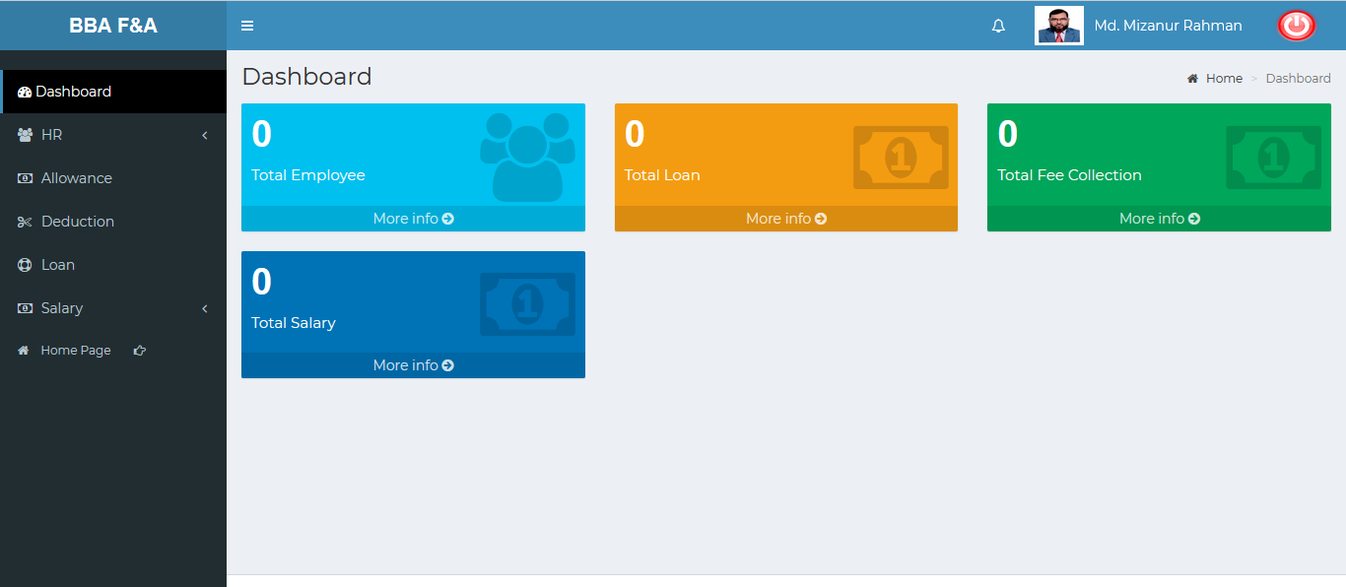

Figure 3: Dashboard of MIS payroll (sub module).

There are four segments on the right side of the MIS Payroll Management Dashboard Such as **Total Employee, Total Loan ,Total Fee Collection** And **Total Salary.**

To get the details info about (**Total Employee, Total Loan ,Total Fee Collection, Total Salary**) just click on the More info link after that it will redirect to the relevant details info page.

# 4.MIS PAYROLL MANAGEMENT MENU OVERVIEW

**MIS Payroll Management Menu Overview**

## 4.1: HR Menu Overview

**Overview of Settings**

Click on the HR menu after that there will appear three (03) sub-menu & they are **Employees , Others** and **Increments.**

### 4.1.1.1: Employees (HR) View of Employees details

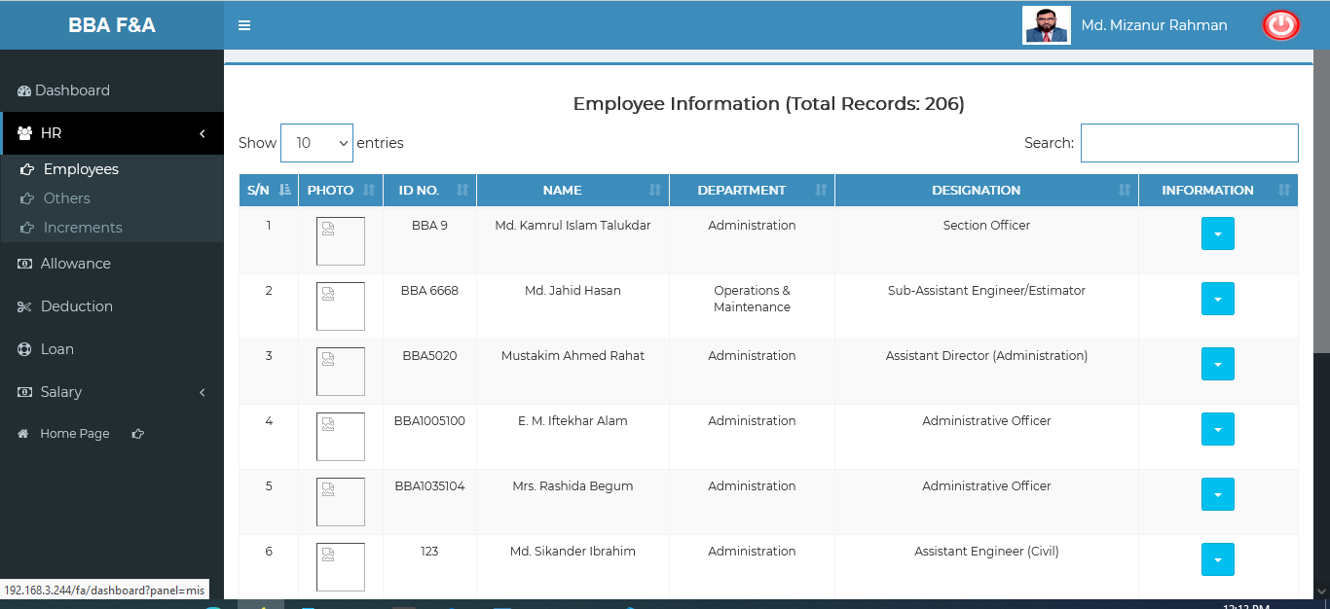

Figure 4.1.1.1: employees(HR) view of employees details

### 4.1.1.2: Employees (HR) View of Employee (Personal) Data

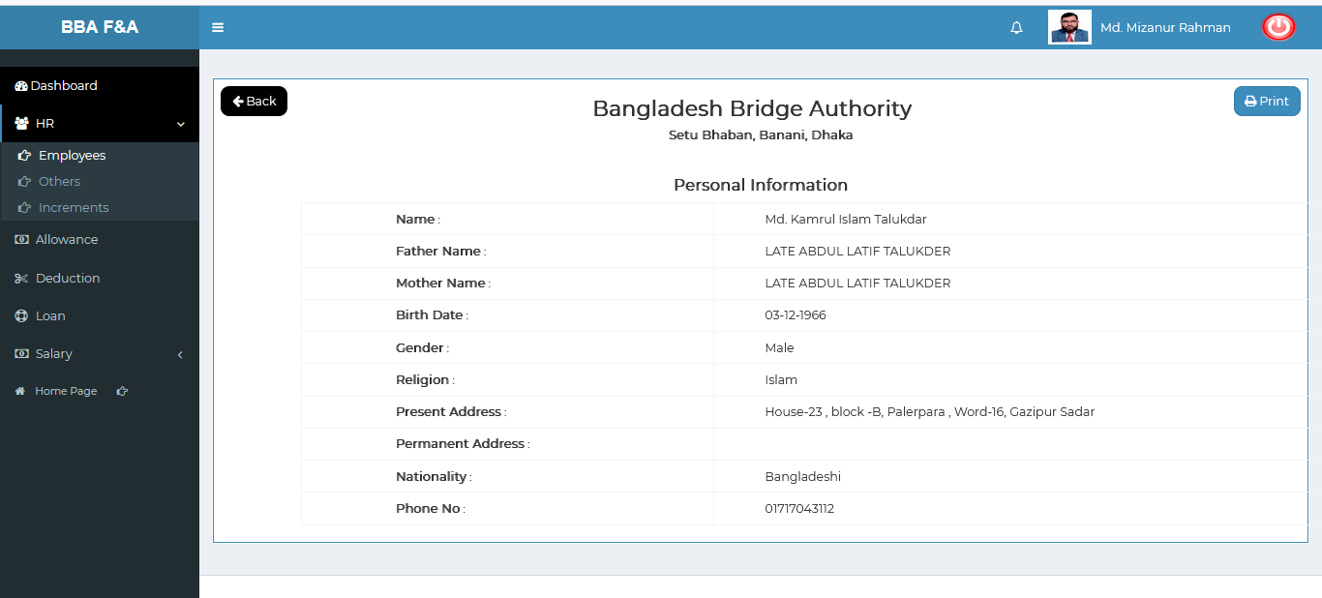

Figure 4.1.1.2: employees (HR)View of employee (personal) data

### 4.1.1.2.1: Employees (HR) Employee (Personal) Data Print

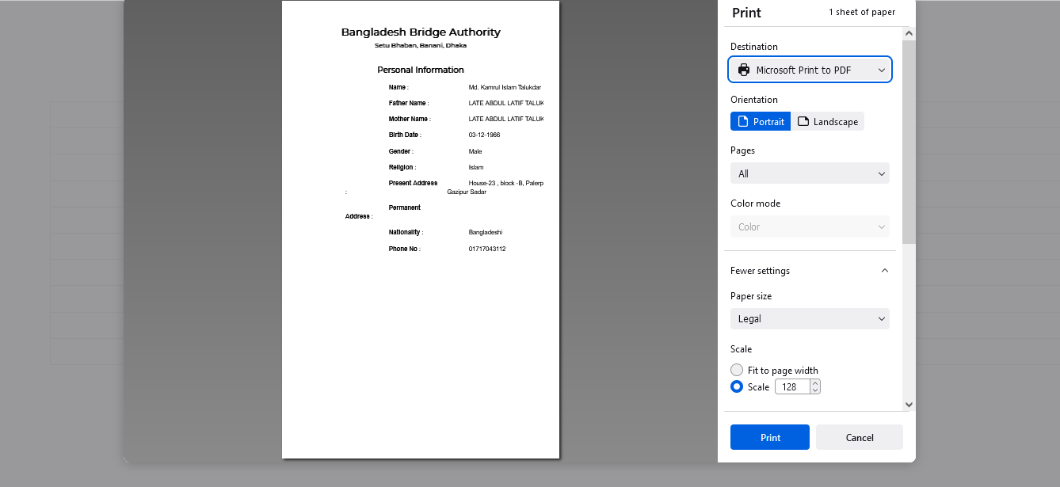

Figure 4.1.1.2.1: employees (HR) employee (personal) data Print

### 4.1.1.3: Employees (HR) View of Employee (Others) Data

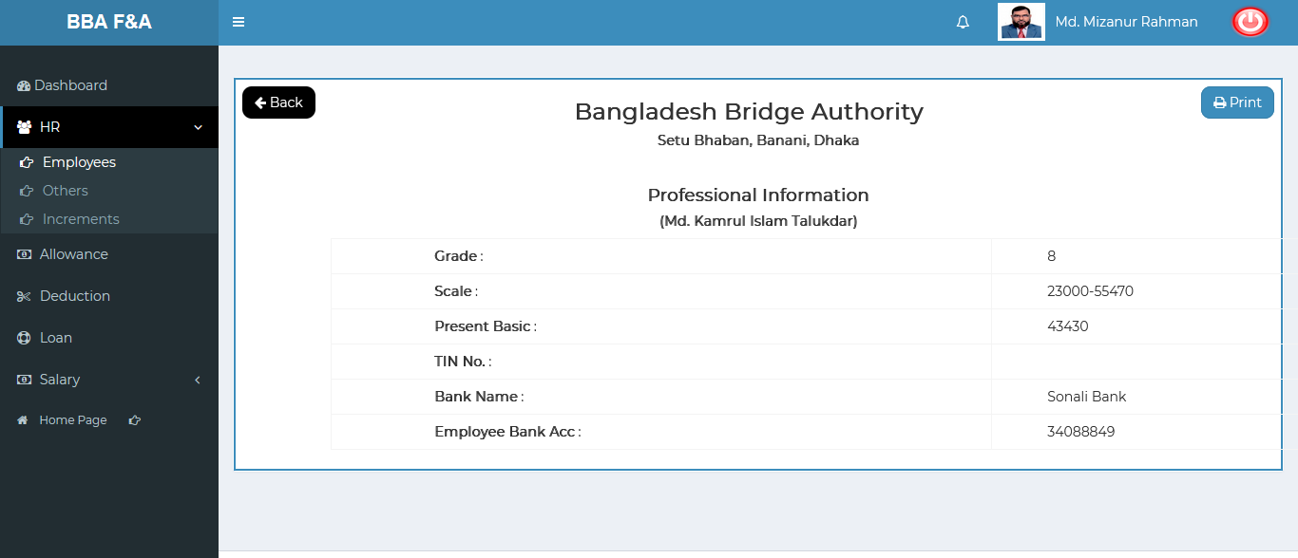

Figure 4.1.1.3: employees (HR)View of employee (others) data

### 4.1.1.3.1: Employees (HR) Employee (Others) Data Print

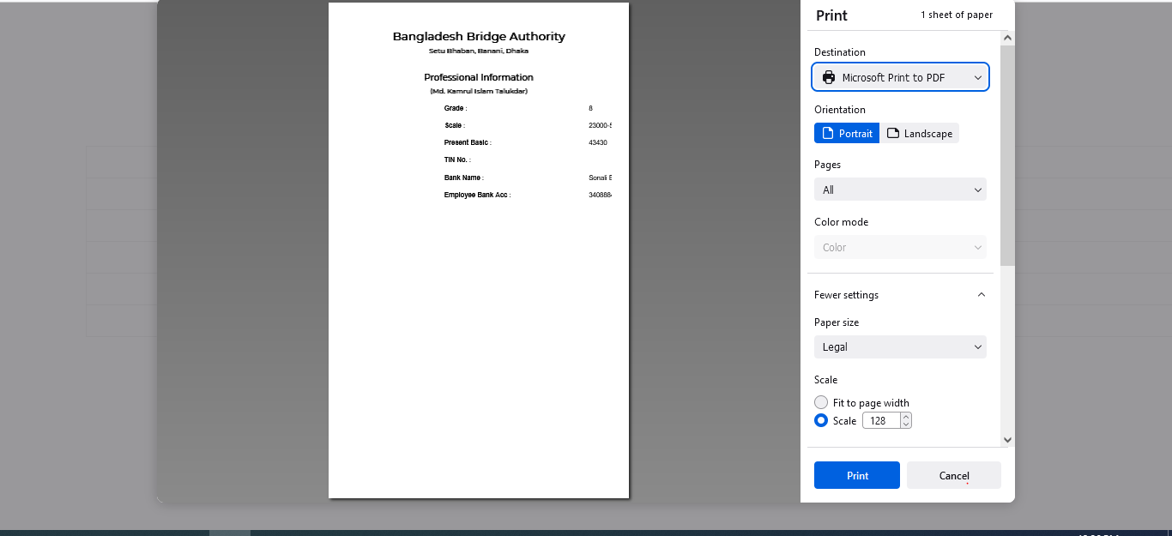

Figure 4.1.1.3.1: employees (HR) employee (others) data Print

### 4.1.1.4: Employees (HR) View of Employee (Increment) Data

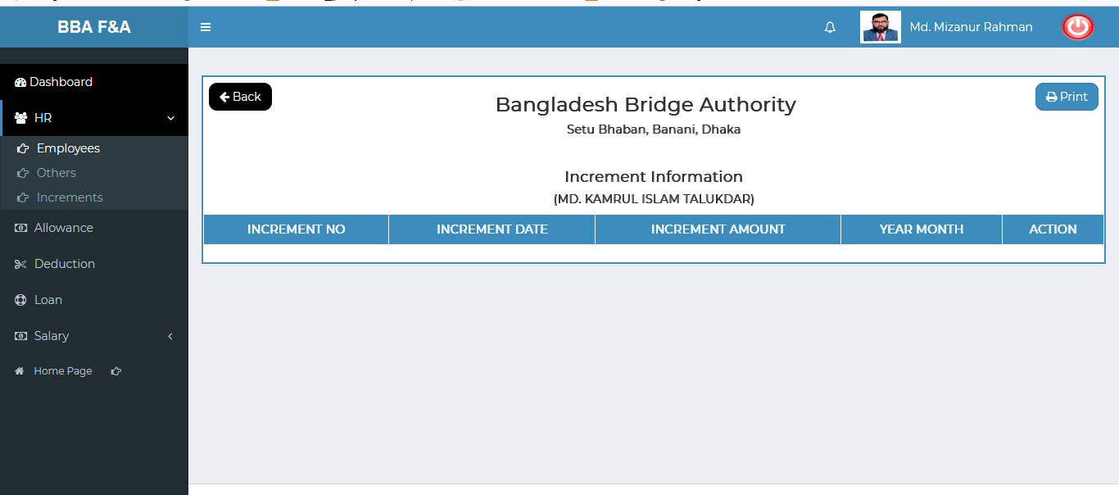

Figure 4.1.1.4: employees (HR)View of employee (Increment) data

### 4.1.1.4.1: Employees (HR) Employee (Increment) Data Print

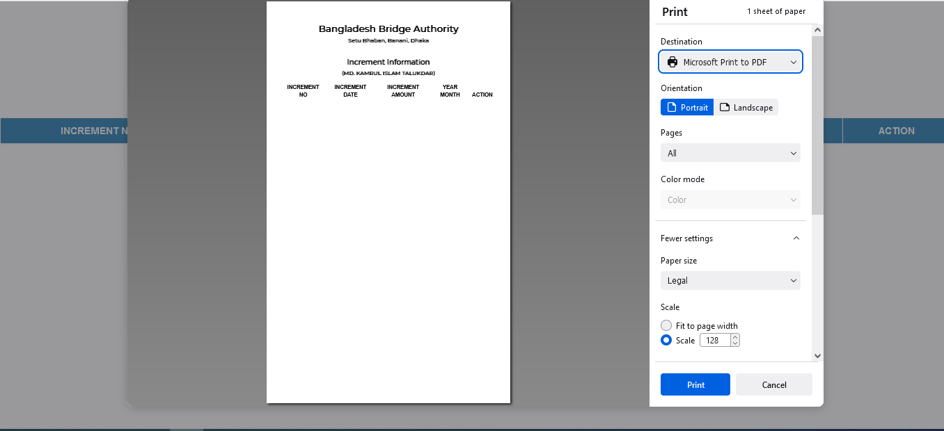

Figure 4.1.1.4.1: employees (HR) employee (increment) data Print

### 4.1.1.5: Employees (HR) View of Employee (Training) Data

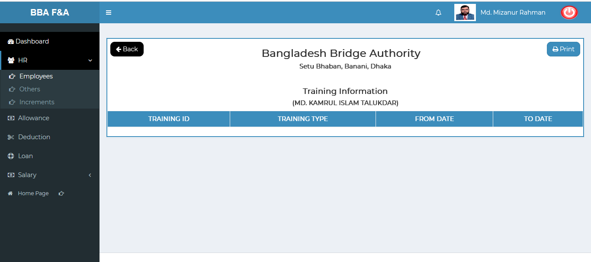

Figure 4.1.1.5: employees (HR)View of employee (Training) data

### 4.1.1.5.1: Employees (HR) Employee (Training) Data Print

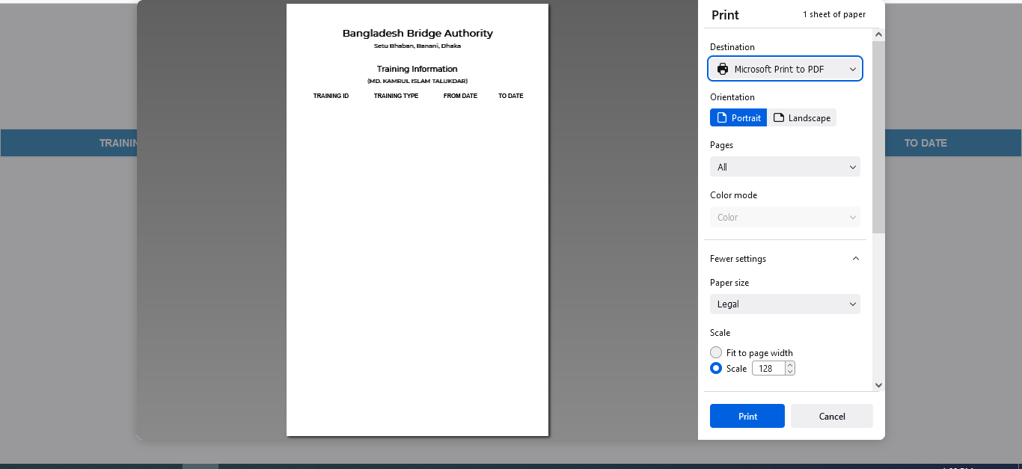

Figure 4.1.1.5.1: employees (HR) employee (training) data Print

### 4.1.1.6: Employees (HR) Search

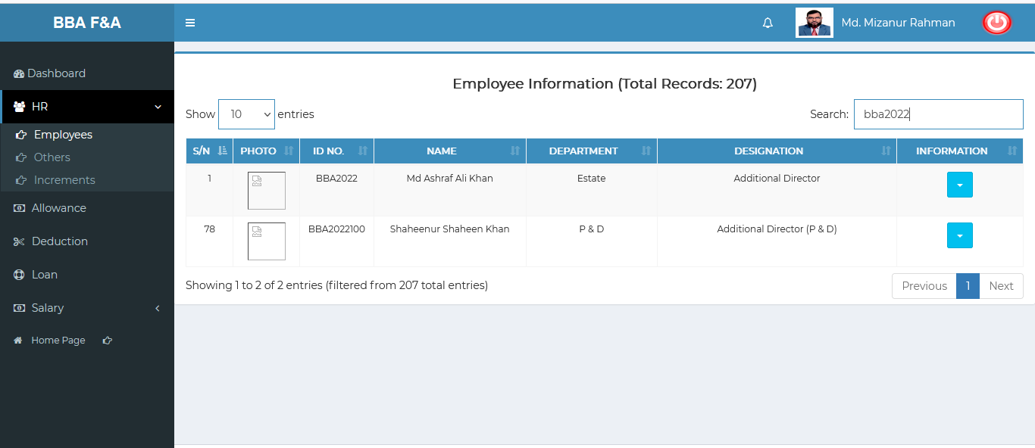

Figure 4.1.1.6: employees (HR) search

### 4.1.2.1: Others (HR) Add Others Info input field

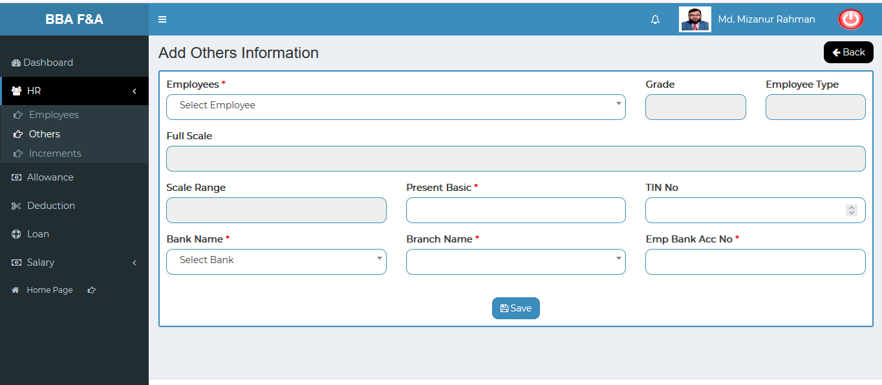

Figure 4.1.2.1: others (HR) add others input field

### 4.1.2.2: Others (HR) View of Details

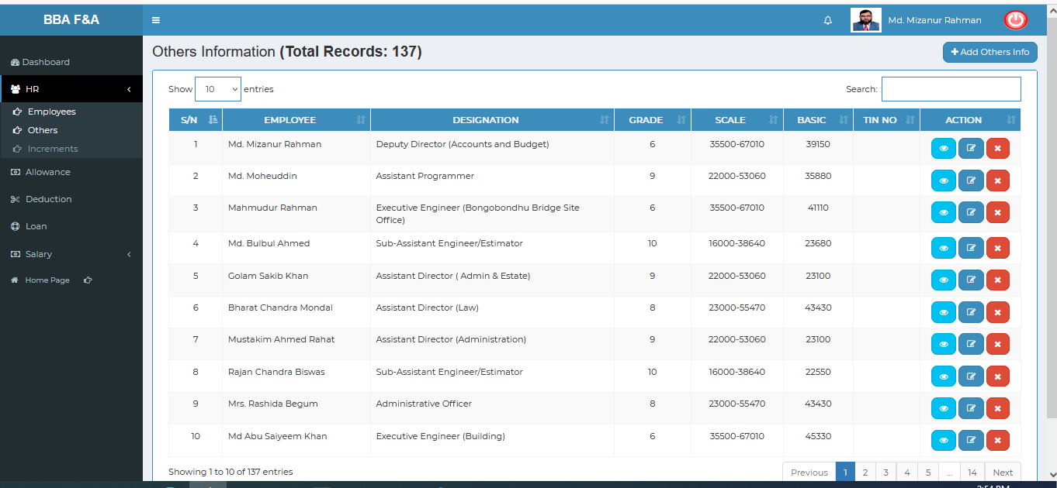

Figure 4.1.2.2: others (HR) View of details others information

### 4.1.2.3: Others (HR) View of Single Details

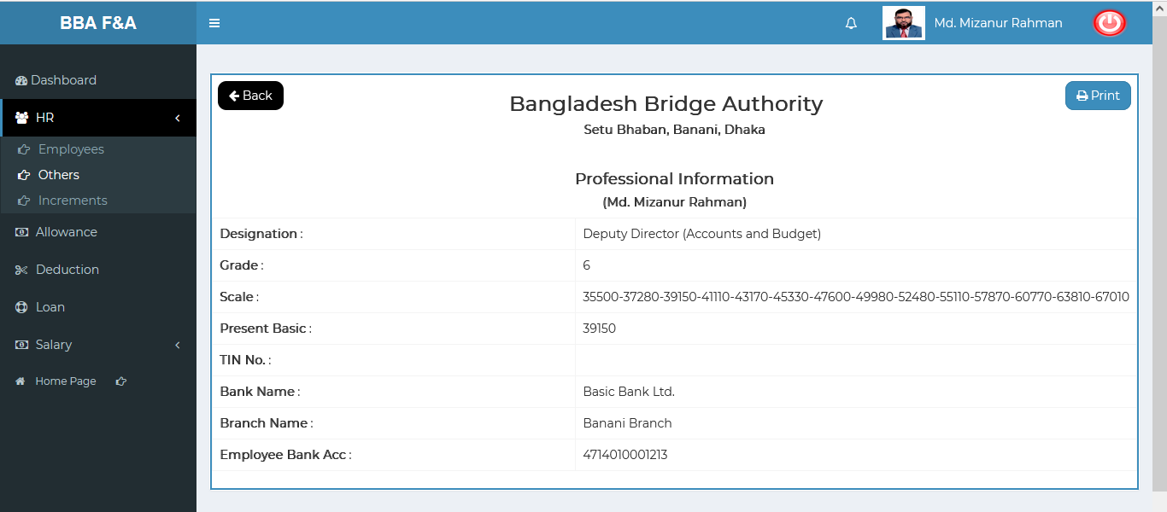

Figure 4.1.2.3: others (HR) View of single details others information

### 4.1.2.3.1: Others (HR) View of Single Details Print

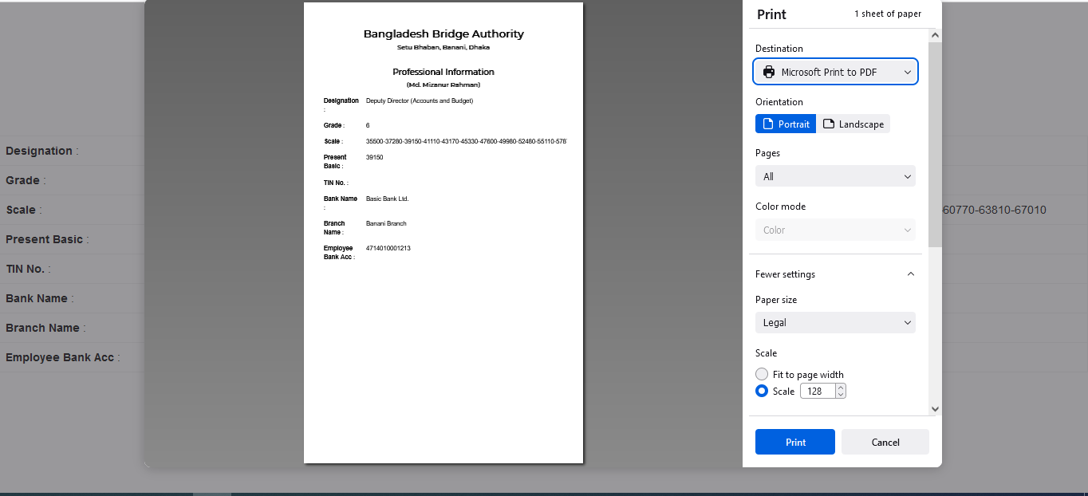

Figure 4.1.2.3.1: others (HR) View of single details print

### 4.1.2.4: Others (HR) Edit

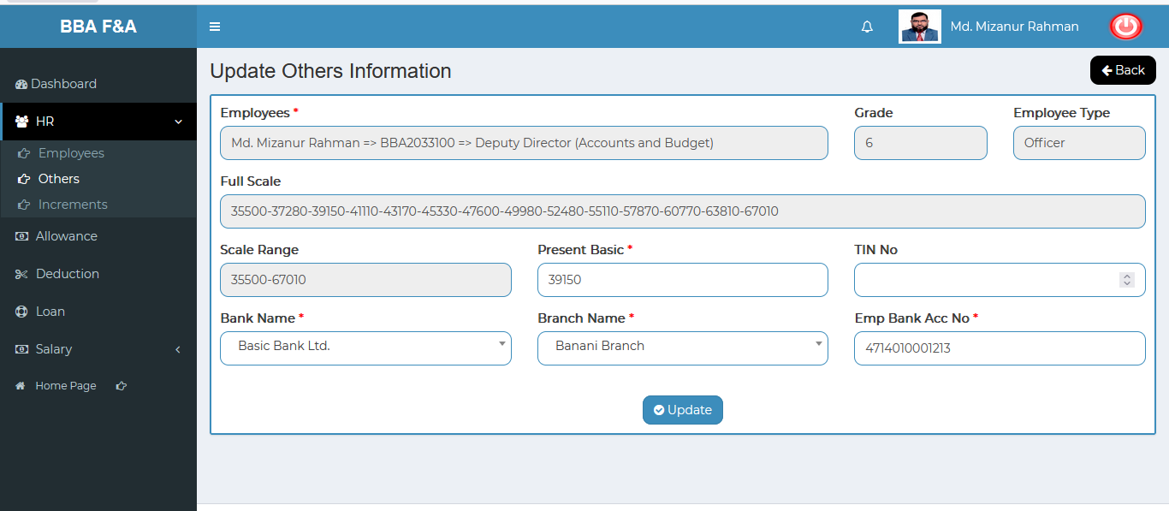

Figure 4.1.2.4: others (HR) edit

### 4.1.2.5: Others (HR) Delete

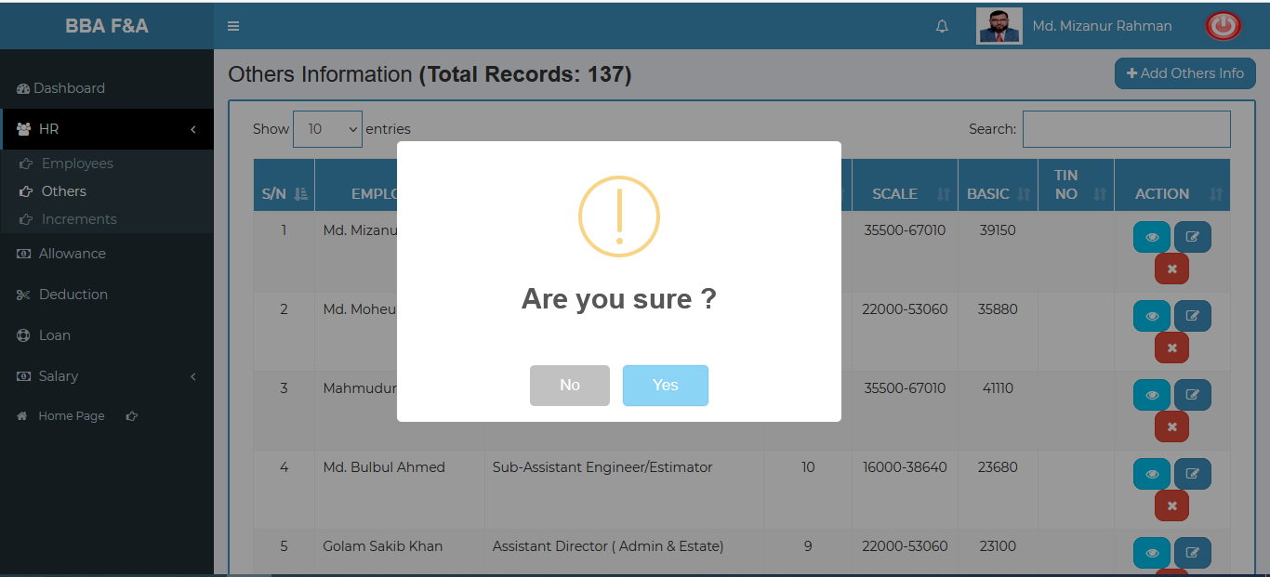

Figure 4.1.2.5: others (HR) Delete

### 4.1.2.6: Others (HR) Search

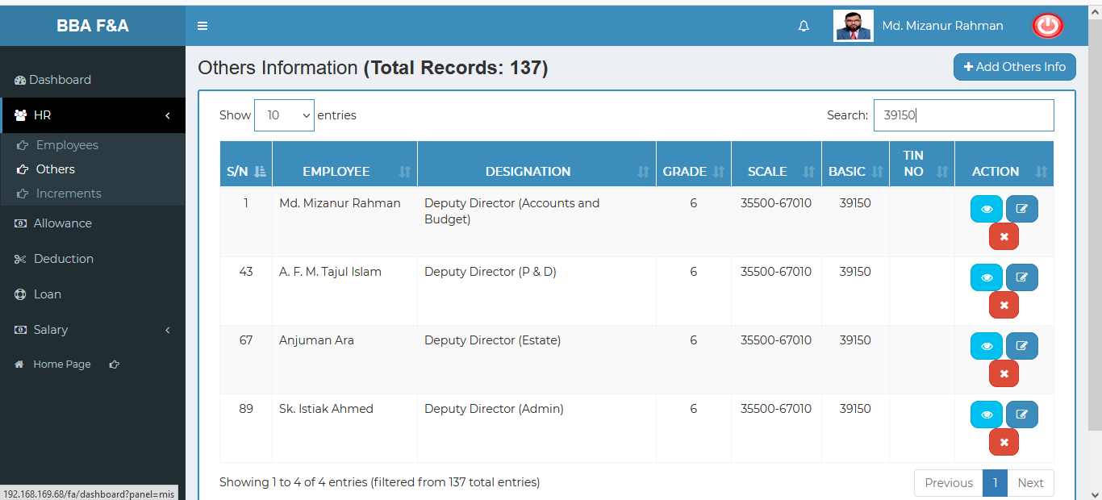

Figure 4.1.2.6: others (HR) search

### 4.1.3.1: Increments (HR) Add New Increment input field

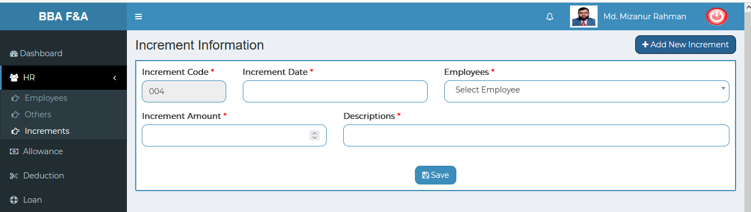

Figure 4.1.3.1: Increments (HR) add new increment input field

### 4.1.3.2: Increments (HR) View of details

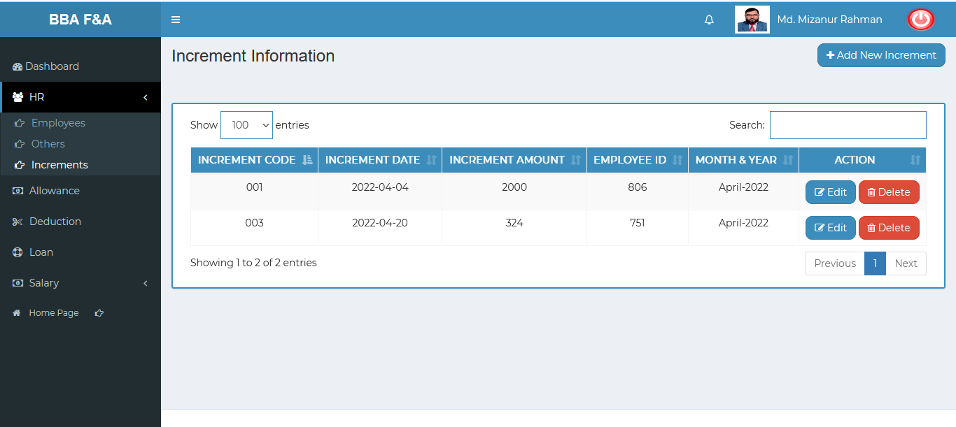 Figure 4.1.3.2: Increments (HR) view of details

### 4.1.3.3: Increments (HR) Edit

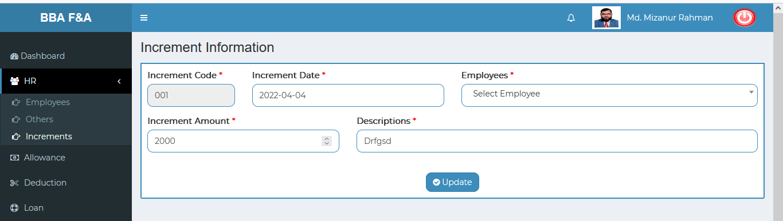

Figure 4.1.3.3: Increments (HR) edit

### 4.1.3.4: Increments (HR) Delete

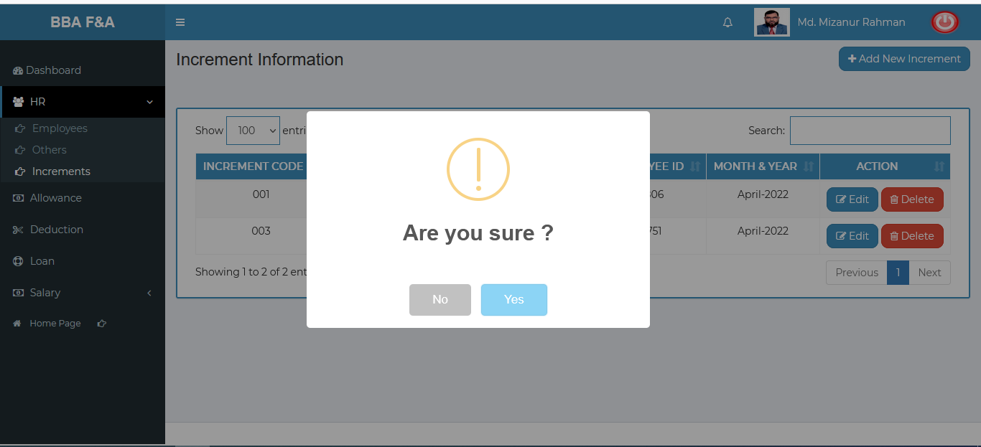 Figure 4.1.3.4: Increments (HR) delete

### 4.1.3.5: Increments (HR) Search

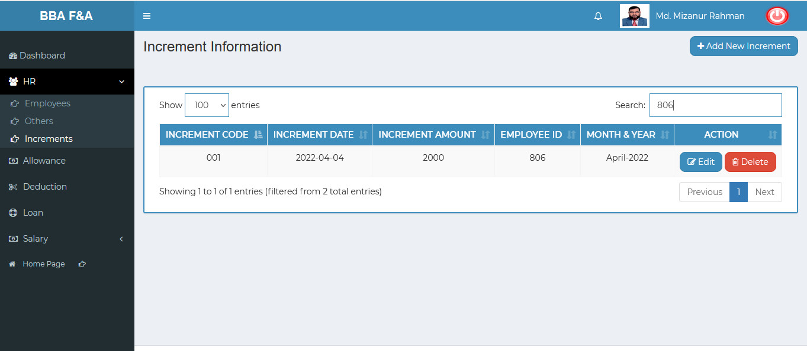

Figure 4.1.3.5: Increments (HR) Search

## 4.2: Allowance Menu Overview

**Overview of Allowance**

### 4.2.1.1: (Allowance) Entering allowance page input field

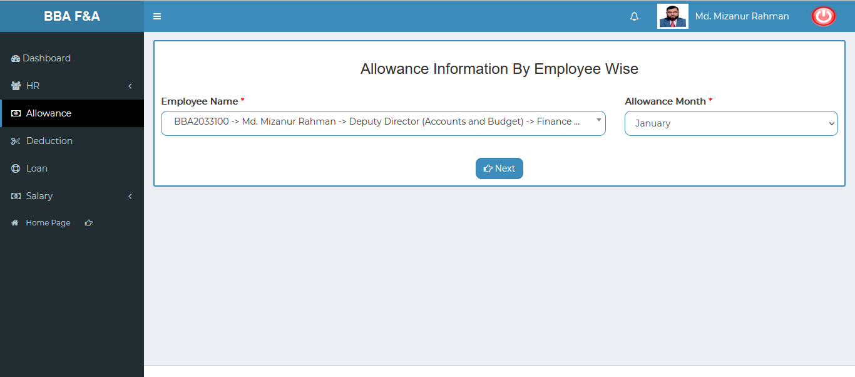

Figure 4.2.1.1: (allowance) entering allowance page input field

### 4.2.1.2: (Allowance) Adding & updating allowance input field

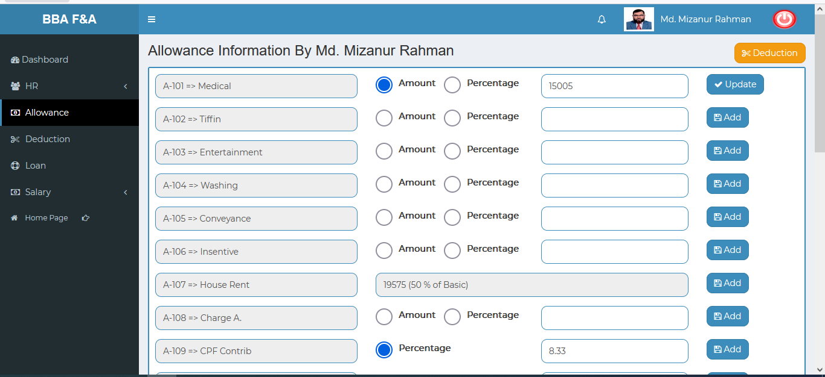

Figure 4.2.1.2: (allowance) adding & updating allowance input field

## 4.3: Deduction Menu Overview

**Overview of Deduction**

### 4.3.1.1: (Deduction) Entering the Deduction page input field

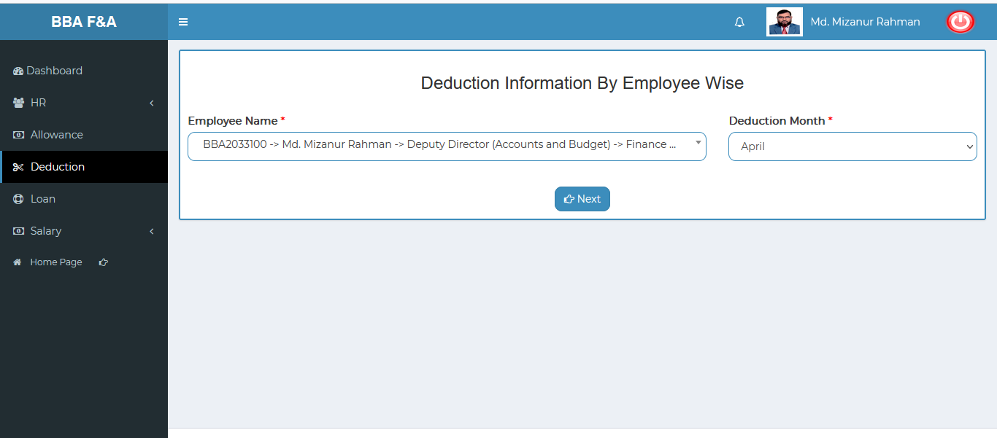

Figure 4.3.1.1: (allowance) entering deduction page input field

### 4.3.1.2: (Deduction) Adding & updating the deduction input field

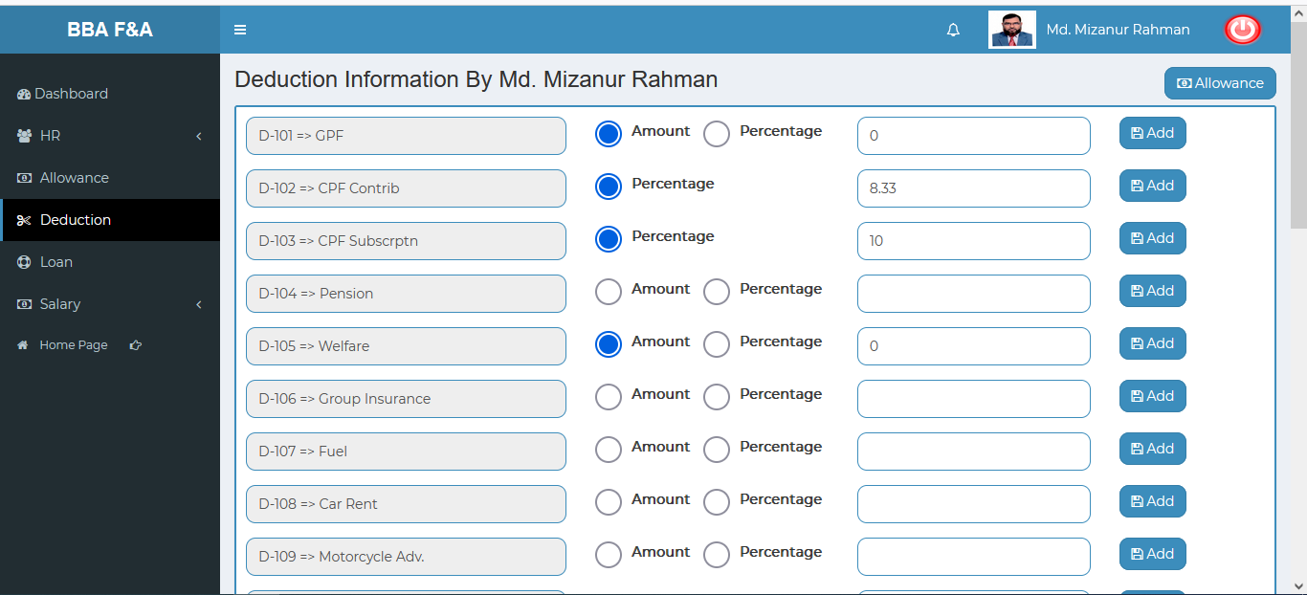

Figure 4.3.1.2: (deduction) adding & updating deduction input field

## 4.4: Loan Menu Overview

**Overview of Loan**

### 4.4.1.1: (Loan) Add Loan input field

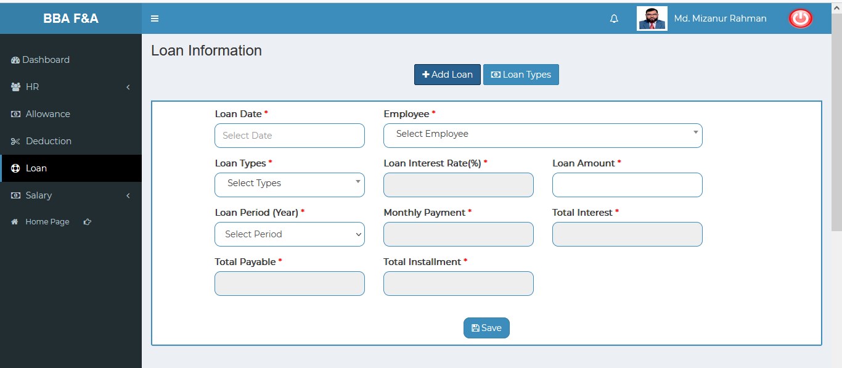

Figure 4.4.1.1: (deduction) add loan input field

### 4.4.1.2: (Loan) View of details

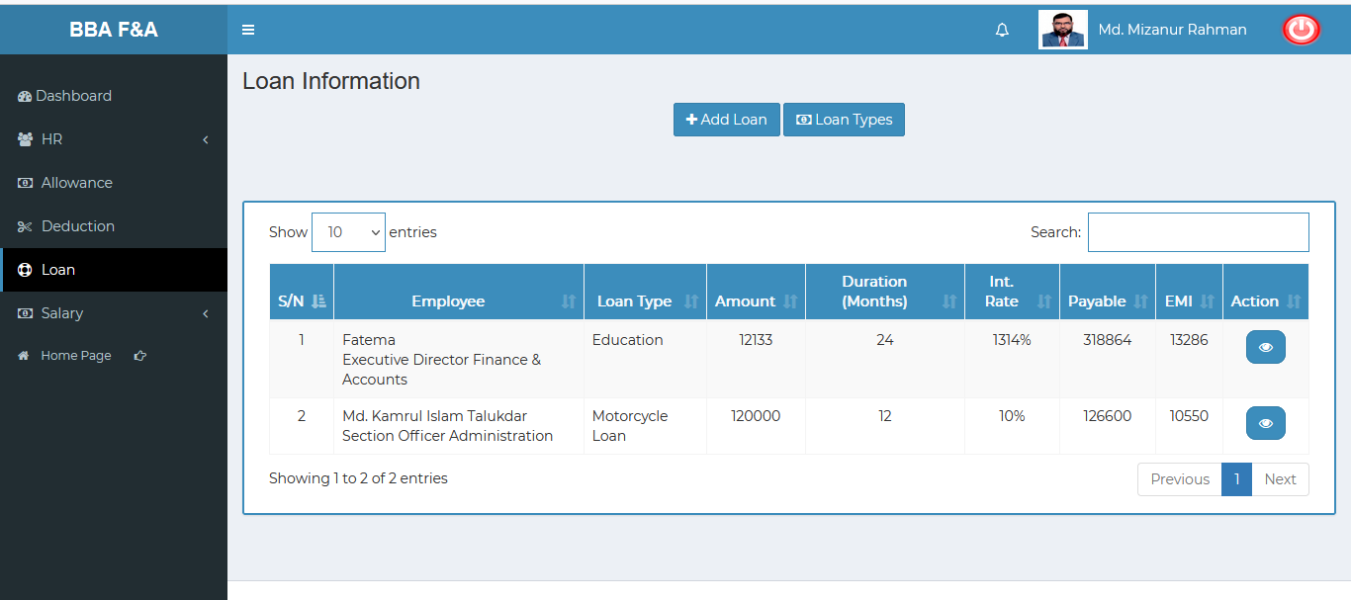

Figure 4.4.1.2: (Loan) view of details

### 4.4.1.3: (Loan) View of single employee details info

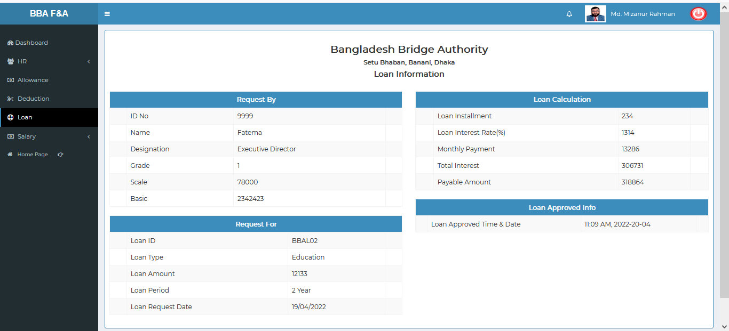

Figure 4.4.1.3: (Loan) view of single employee details info

### 4.4.1.4: (Loan) Add Loan types input field

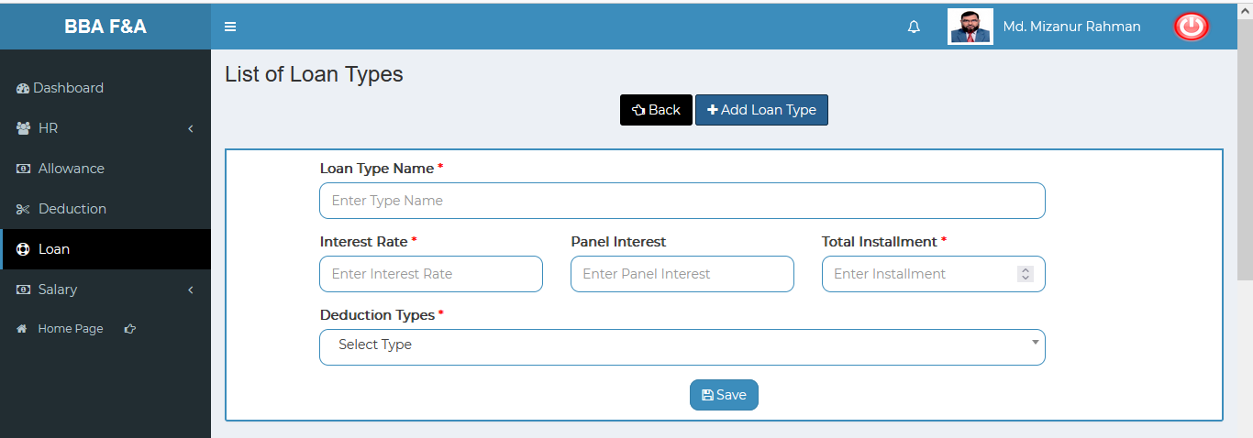

Figure 4.4.1.4: (Loan) add loan types input field

### 4.4.1.5: (Loan)View of Add Loan types Details

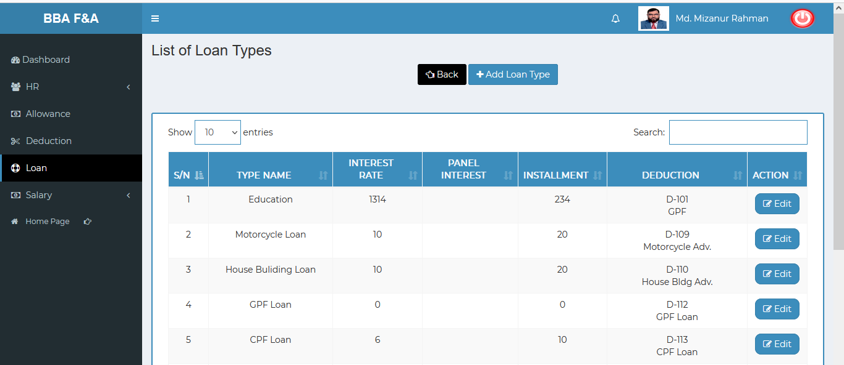

Figure 4.4.1.5: (Loan) view of add loan types details

### 4.4.1.6: (Loan) Add Loan types Details Edit

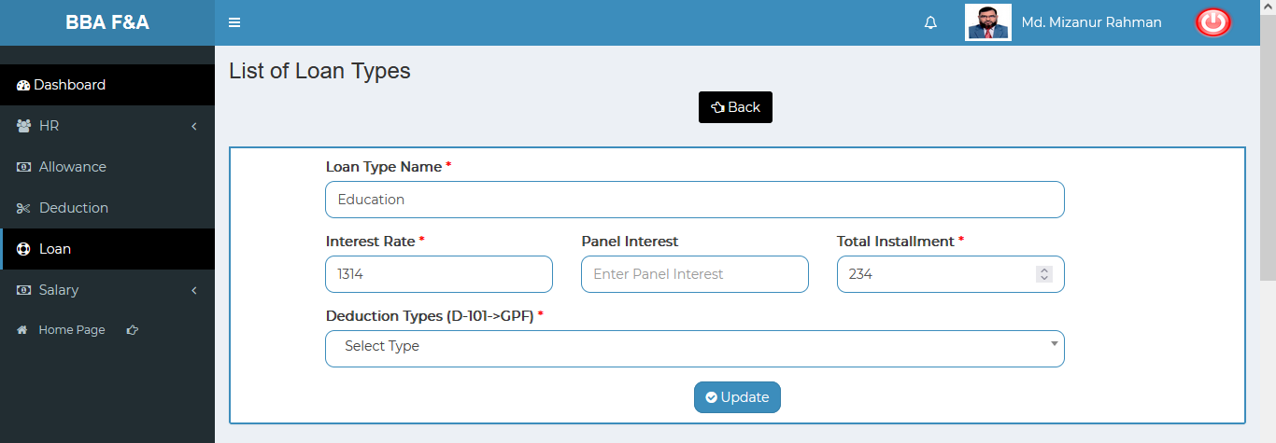

Figure 4.4.1.6: (Loan) add loan types details edit

### 4.4.1.7: (Loan) Search

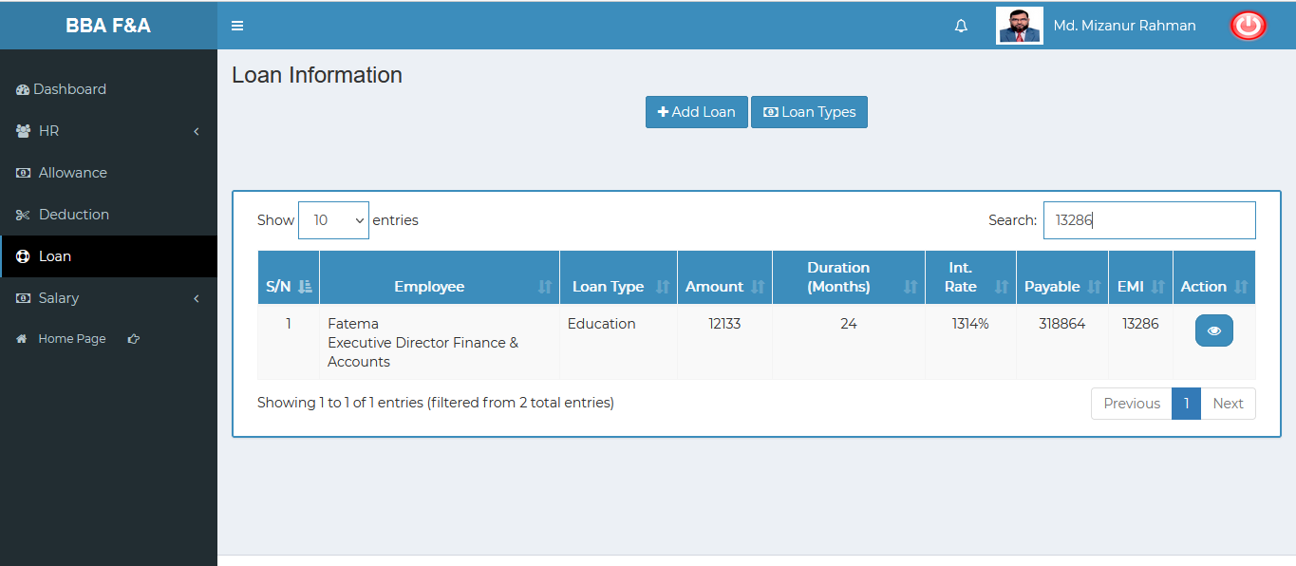

Figure 4.4.1.7: (Loan) search

## 4.5: Salary Menu Overview

**Overview of Salary**

### 4.5.1.1: Salary Process (Salary) Month wise salary process input field

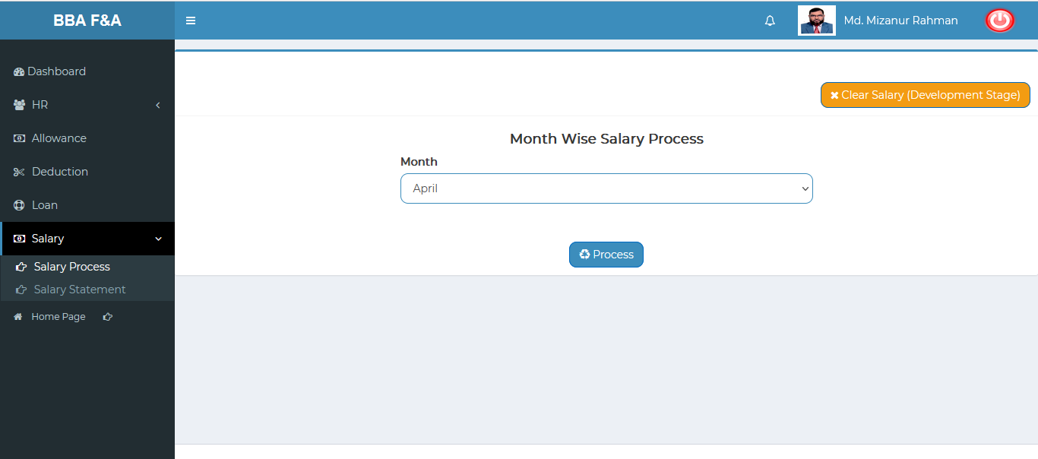

Figure 4.5.1.1: salary process(salary) month wise salary process input field

### 4.5.2.1: Salary Statement (Salary) Month and Grade wise salary input field

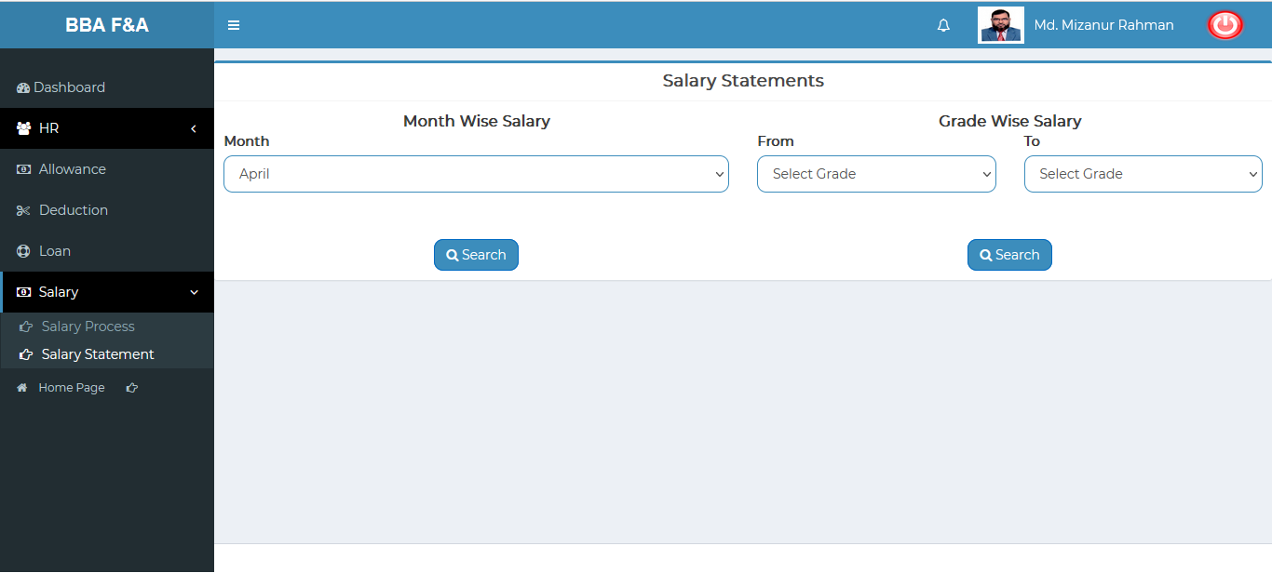

Figure 4.5.2.1: salary statement(salary) month & grade-wise salary input field

### 4.5.2.2: Salary Statement (Salary) Month wise salary report

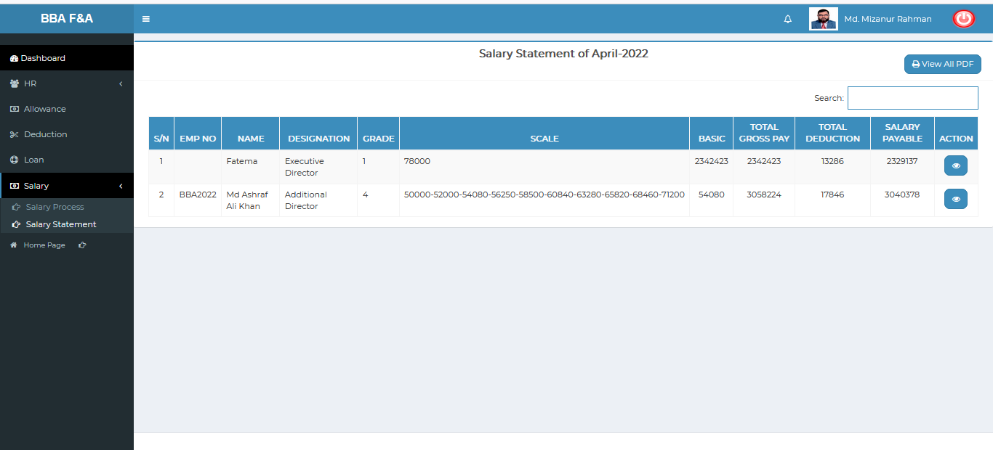

Figure 4.5.2.2: salary statement(salary) view of month-wise salary report

### 4.5.2.3: Salary Statement (Salary) Month wise salary report (Single Employee Details)

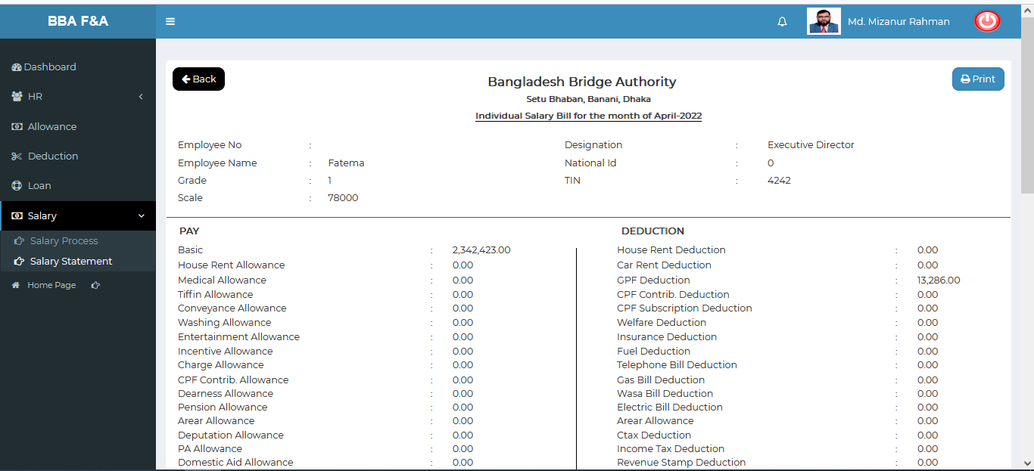 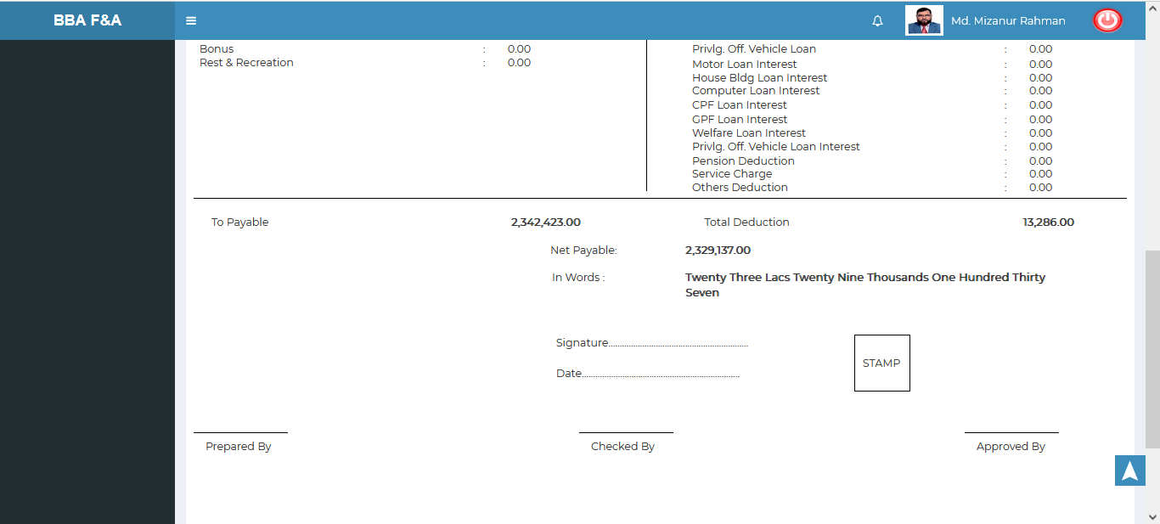

Figure 4.5.2.3: salary statement(salary) month wise salary report (single employee details)

### 4.5.2.4: Salary Statement (Salary) Month wise salary report (Month wise salary details)

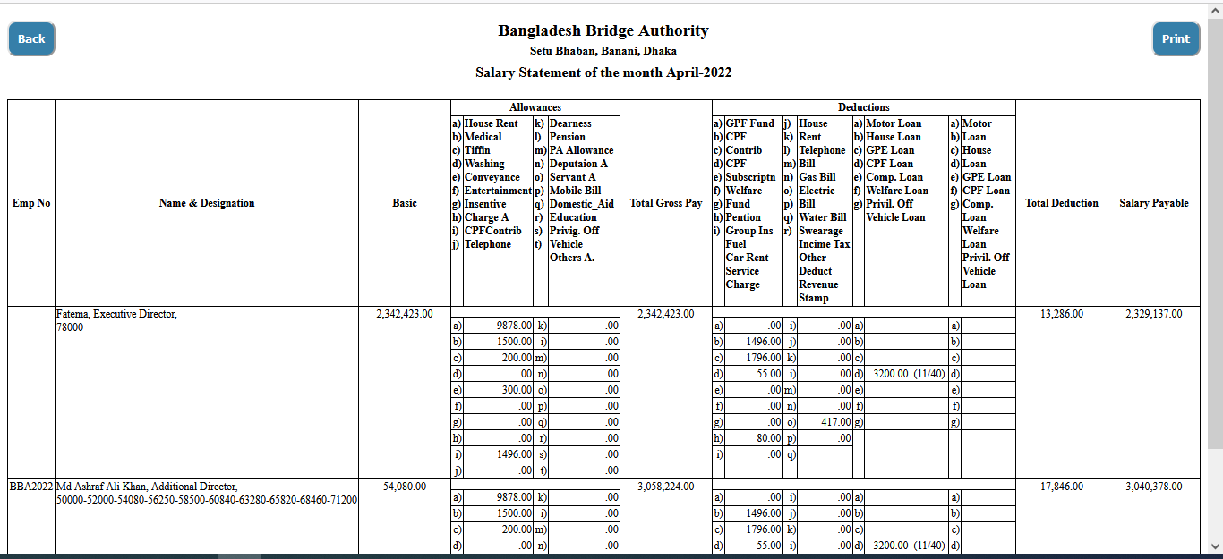

Figure 4.5.2.4: salary statement(salary) month wise salary report (month-wise salary details)

### 4.5.2.5: Salary Statement (Salary) Month wise salary report (Month wise salary details) Print

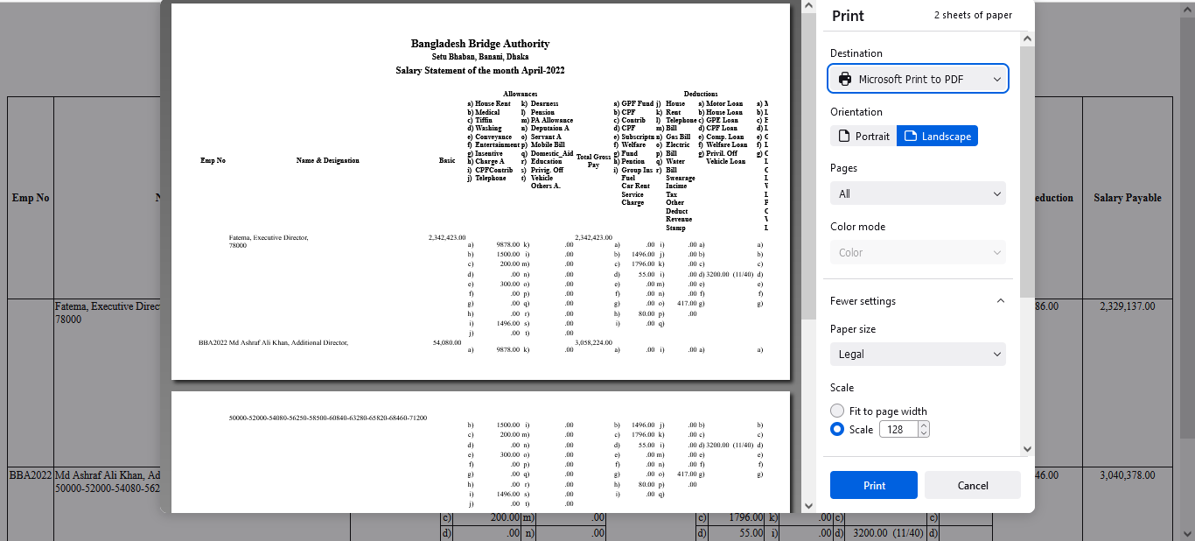

Figure 4.5.2.5: salary statement(salary) month wise salary report (month-wise salary details) print

# 5.CPF MANAGEMENT (SUB MODULE)

After clicking into CPF Management, it will redirect to the (CPF Sub Module) dashboard with some menus.

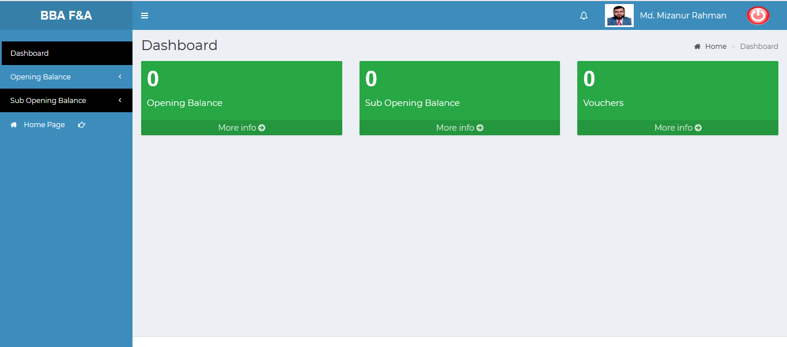

Figure 5: Dashboard of CPF (sub module)

There are three segments on the right side of the CPF Management Dashboard Such as **Opening Balance, Sub Opening Balance ,Vouchers .**

To get the details info about (**Opening Balance, Sub Opening Balance, and Vouchers**) just click on the More info link after that it will redirect to the relevant details info page.

# 6. CPF MANAGEMENT MENU OVERVIEW

**CPF Management Menu Overview**

## 6.1: Opening Balance Menu Overview

**Overview of Opening Balance**

Click on the Opening Balance menu after that there will appear three (03) sub-menu & they are **Create , Manage** and **Report.**

### 6.1.1.1: Create (Opening Balance) Accounts Opening Balance Entry Form

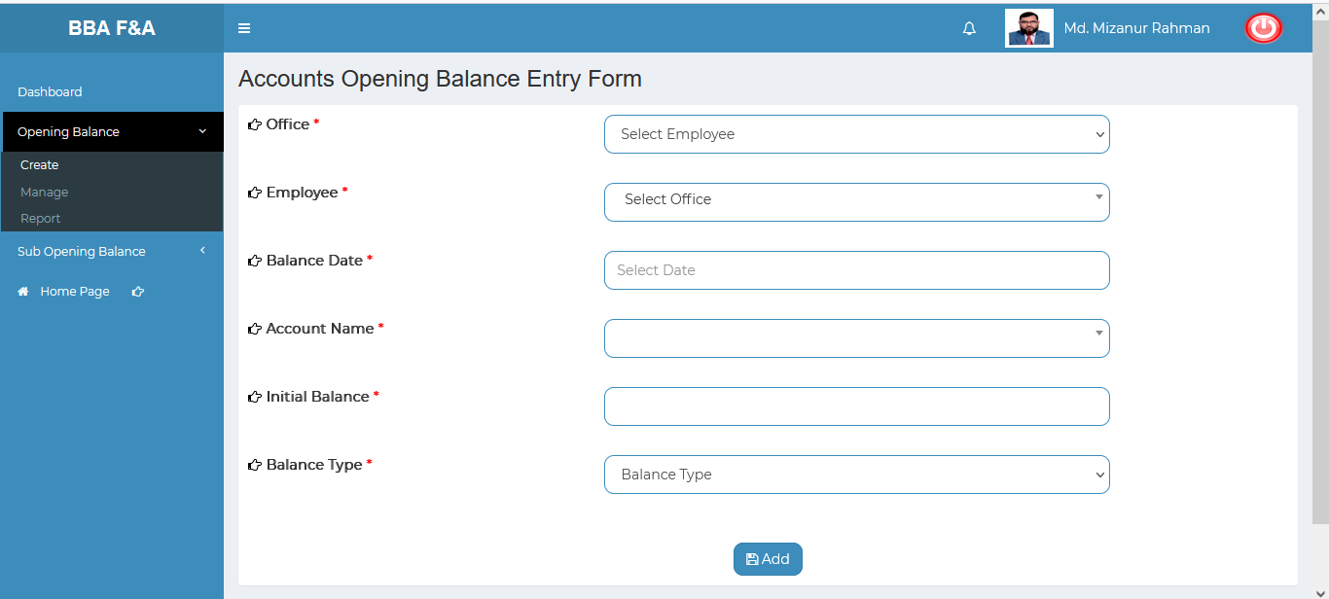

Figure 6.1.1.1: Create (Opening) accounts opening balance entry form

### 6.1.2.1: Manage (Opening Balance) View of Details

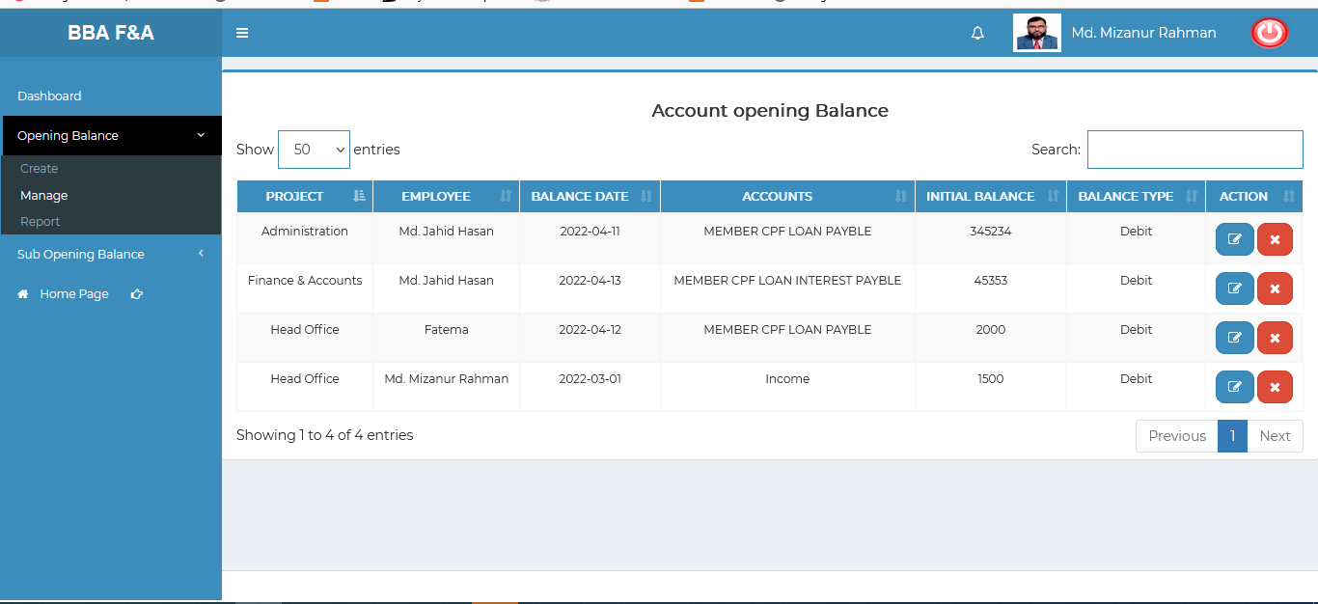

Figure 6.1.2.1: Manage (Opening) accounts opening balance entry form

### 6.1.2.2: Manage (Opening Balance) Update

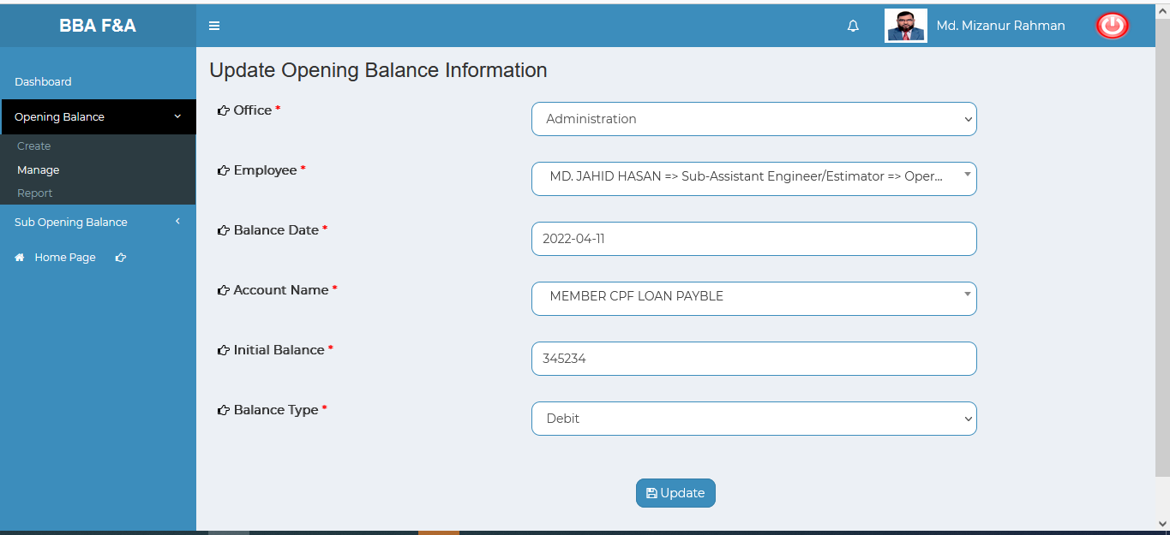

Figure 6.1.2.2: Manage (Opening) Update input form

### 6.1.2.3: Manage (Opening Balance) Delete

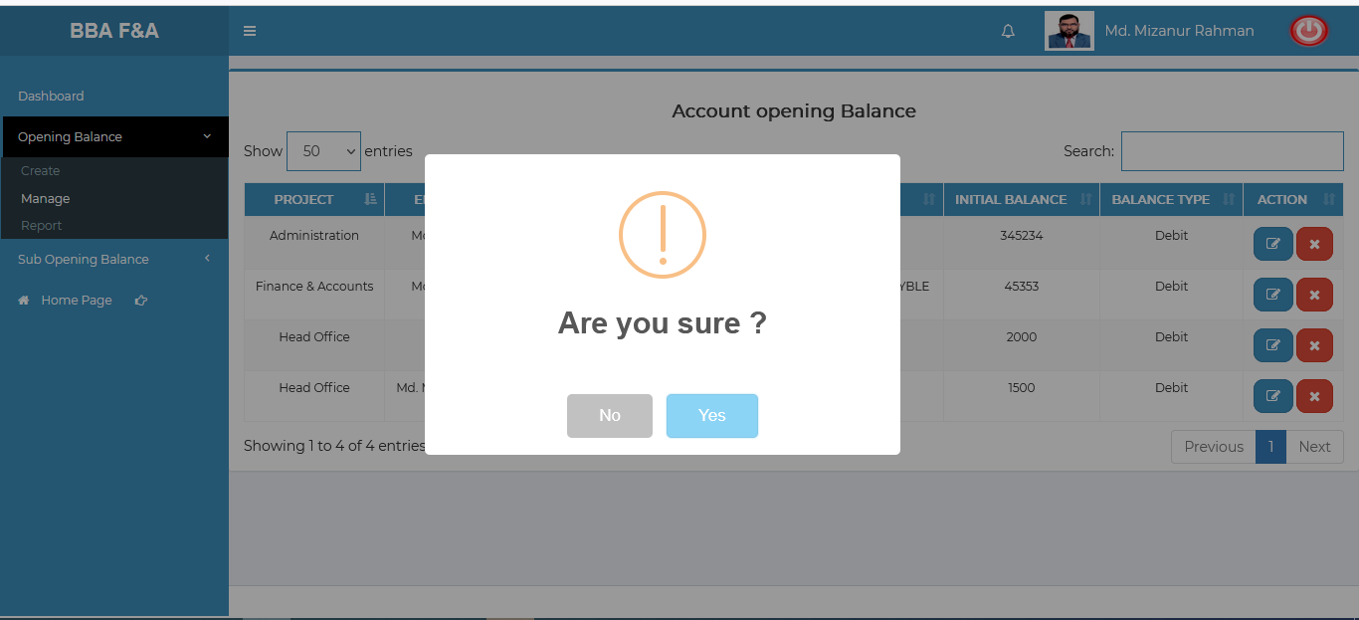

Figure 6.1.2.3: Manage (Opening) delete

### 6.1.2.4: Manage (Opening Balance) Search

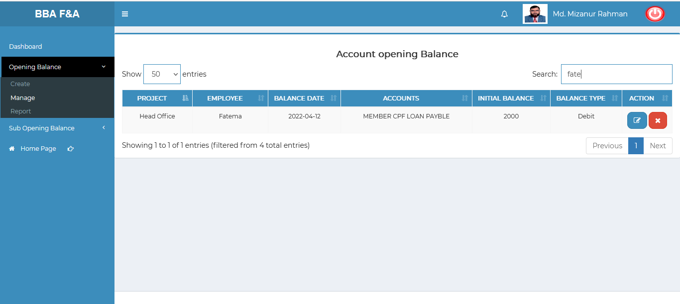

Figure 6.1.2.4: Manage (Opening balance) search

### 6.1.3.1: Report (Opening Balance) incomplete(under processing…..)

## 6.2: Sub Opening Balance Menu Overview

**Overview of Sub Opening Balance**

### 6.2.1.1: Create (Sub Opening Balance) Accounts Sub Opening Balance Entry Form

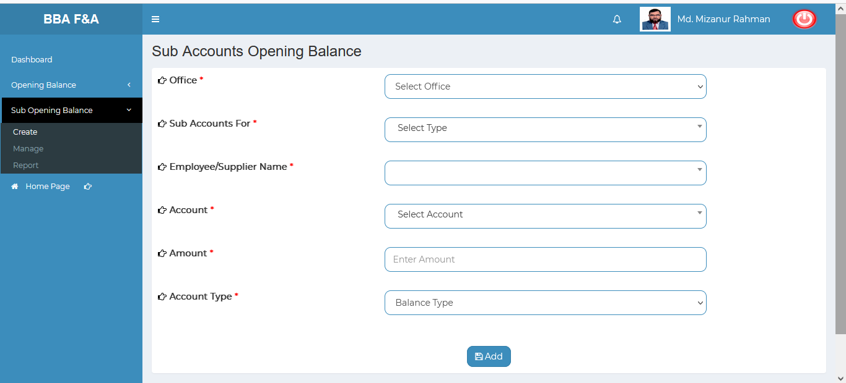

Figure 6.2.1.1: create (Sub Opening balance) Accounts sub opening balance entry form

### 6.2.2.1: Manage (Sub Opening Balance) View of details sub opening balance

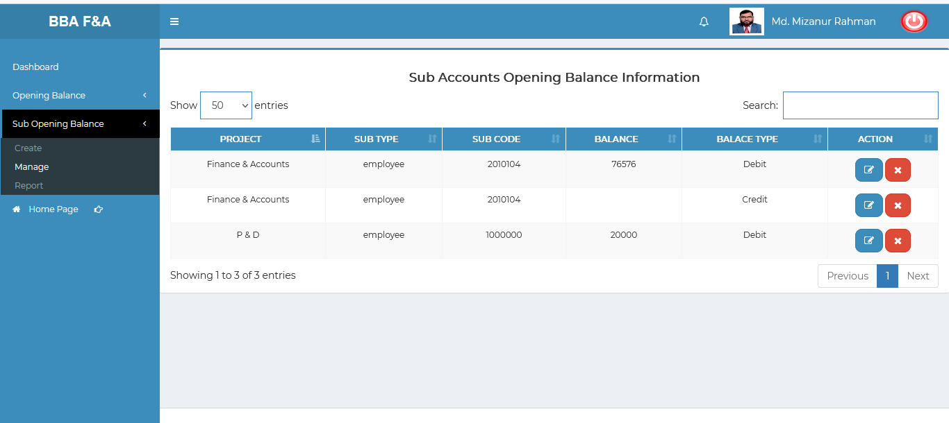

Figure 6.2.2.1: Manage (Sub Opening balance) Accounts sub opening balance entry form

### 6.2.2.2: Manage (Sub Opening Balance) View of details sub opening balance

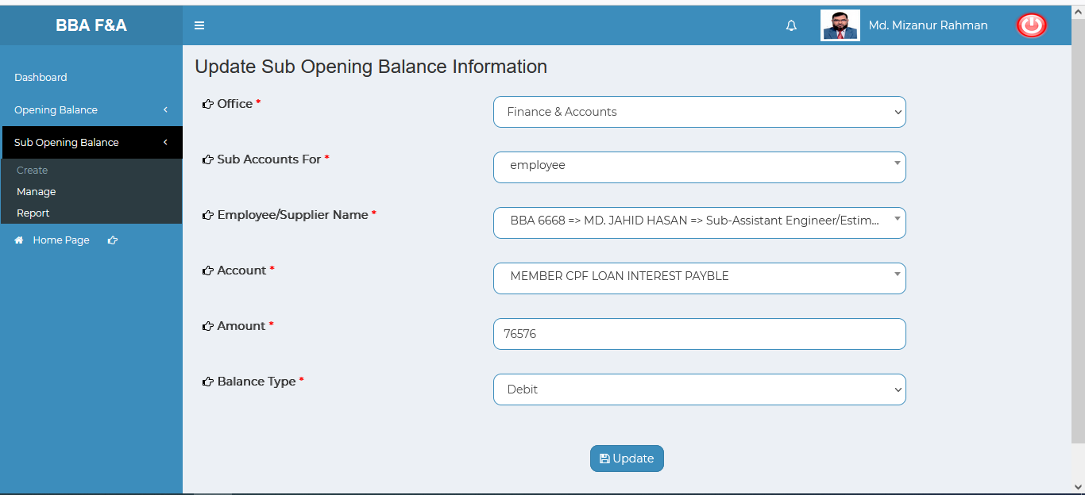

Figure 6.2.2.2: Manage (Sub Opening balance) update sub opening balance information

### 6.2.2.3: Manage (Sub Opening Balance) Delete

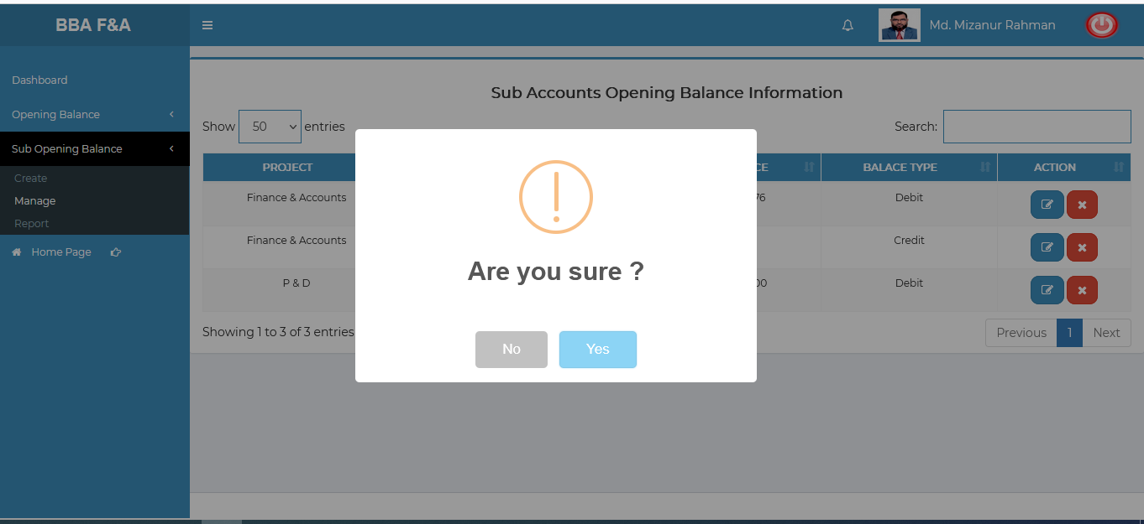

Figure 6.2.2.3: Manage (Sub Opening balance) delete

### 6.2.2.4: Manage (Sub Opening Balance) Search

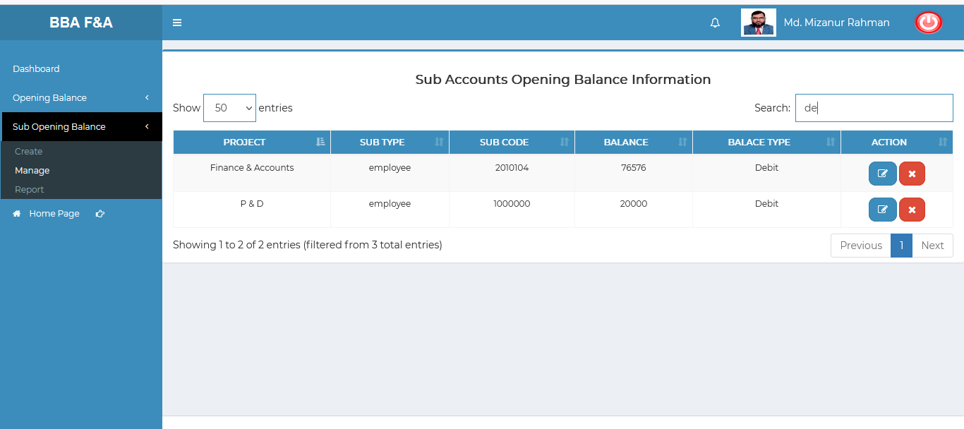

Figure 6.2.2.4: Manage (Sub Opening balance) search

### 6.2.3.1: Report (Sub Opening Balance) incomplete(under processing…..)

# 7.FDR MANAGEMENT (SUB MODULE)

After clicking into FDR Management, it will redirect to the (FDR Sub Module) dashboard with some menus.

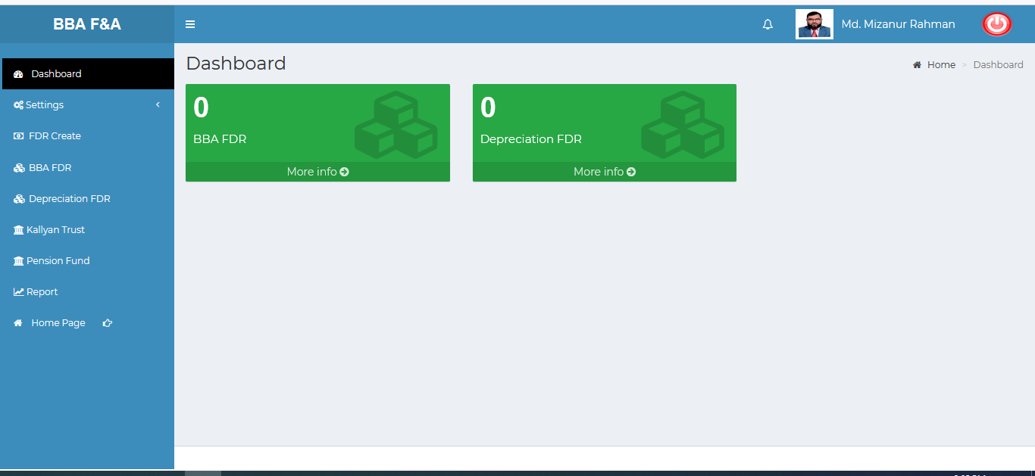

Figure 7: Dashboard of FDR (sub module).

There are two segments on the right side of the FDR Management Dashboard Such as **BBA FDR** & **Depreciation FDR.**

To get the details info about (**BBA FDR , and Depreciation FDR**) just click on the More info link after that it will redirect to the relevant details info page.

# 8.FDR MANAGEMENT MENU OVERVIEW

**FDR Management Menu Overview**

## 8.1: Settings Menu Overview

**Overview of Settings**

### 8.1.1.1: Bank (Settings) Add Bank Entry Form

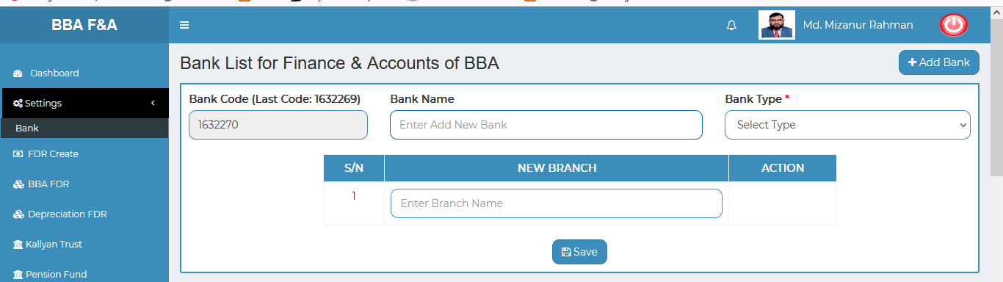

Figure 8.1.1.1: bank (Settings) add bank entry form

### 8.1.1.2: Bank (Settings) View details of bank

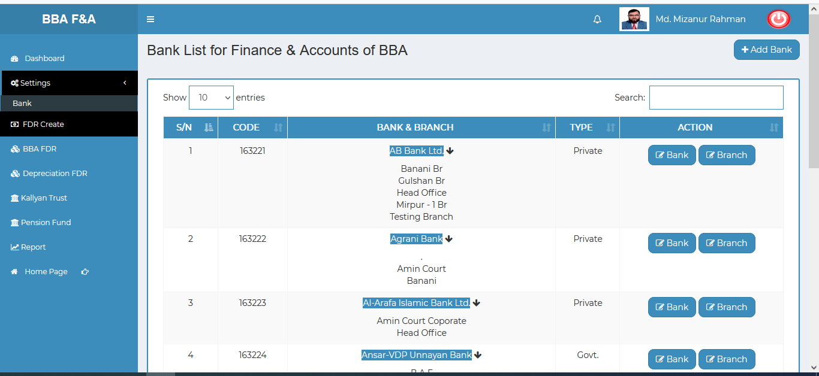

Figure 8.1.1.2: bank(settings) view details of the bank

### 8.1.1.3: Bank (Settings) Update bank type info

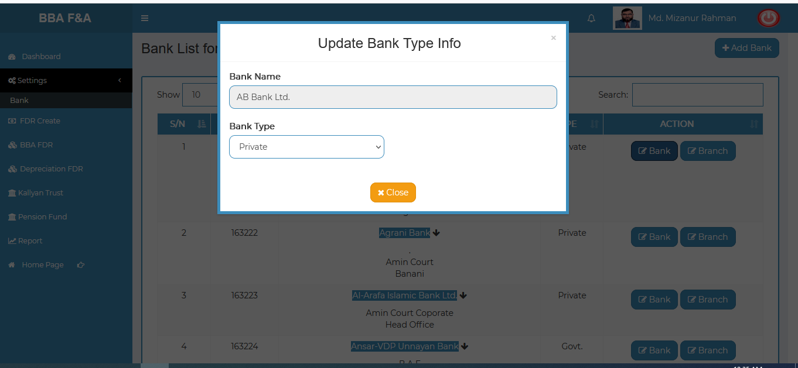

Figure 8.1.1.3: bank(settings) Update bank type info

### 8.1.1.4: Bank (Settings) Update branch type info

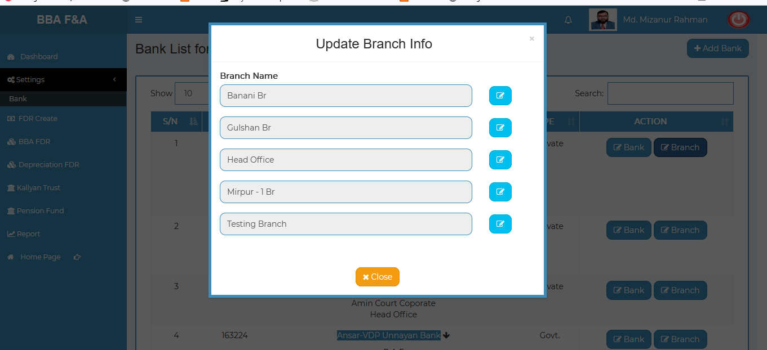

Figure 8.1.1.4: bank(settings) Update branch type info

### 8.1.1.5: Bank (Settings) Search

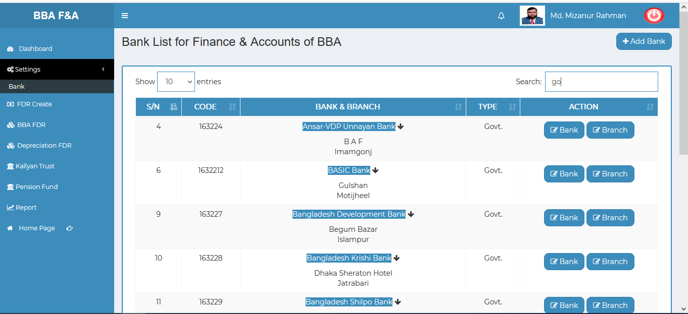

Figure 8.1.1.5: bank(settings) search

## 8.2: FDR Create Menu Overview

**Overview of FDR Create**

### 8.2.1.1: (FDR Create) input field

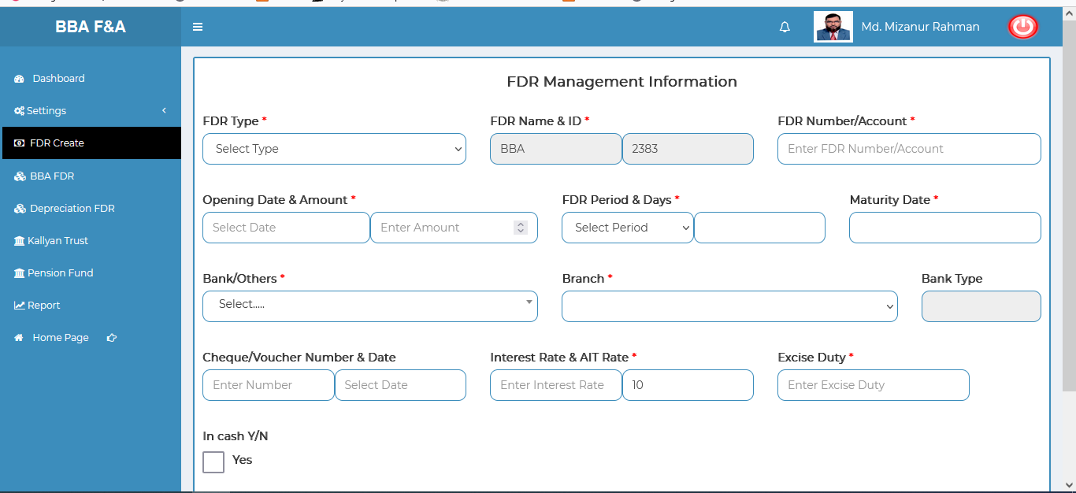

Figure 8.2.1.1: (fdr create) input field

## 8.3: BBA FDR Menu Overview

**Overview of BBA FDR**

### 8.3.1.1: (BBA FDR) View of BBA FDR Information

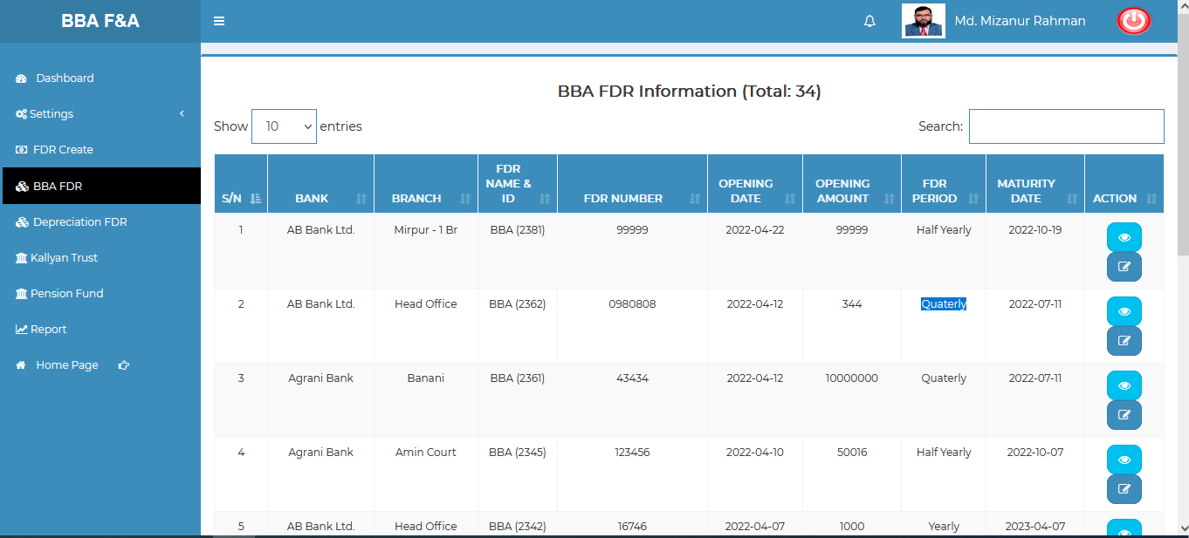

Figure 8.3.1.1:(BBA fdr) view of BBA fdr information

### 8.3.1.2: (BBA FDR) View of Single Details

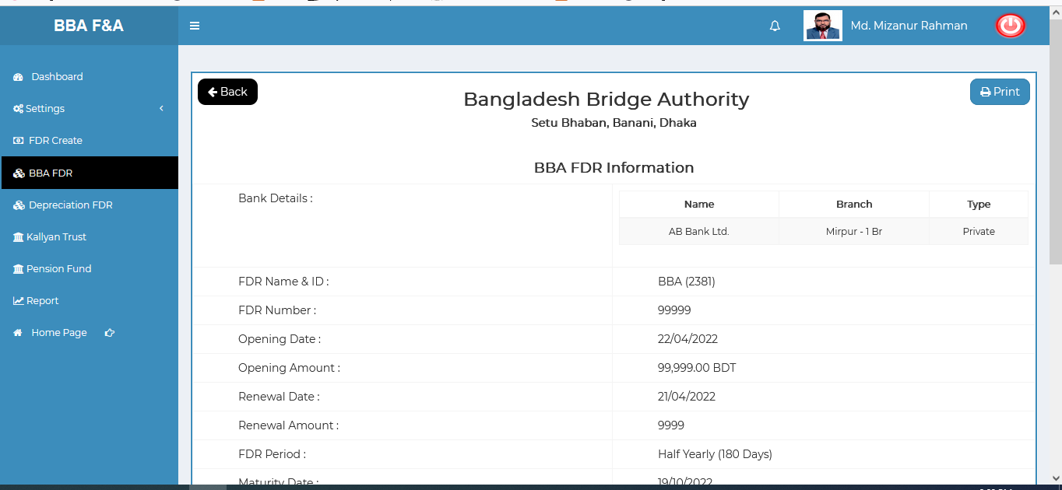

Figure 8.3.1.2: (BBA FDR) view of single details

### 8.3.1.3: (BBA FDR) Update input form

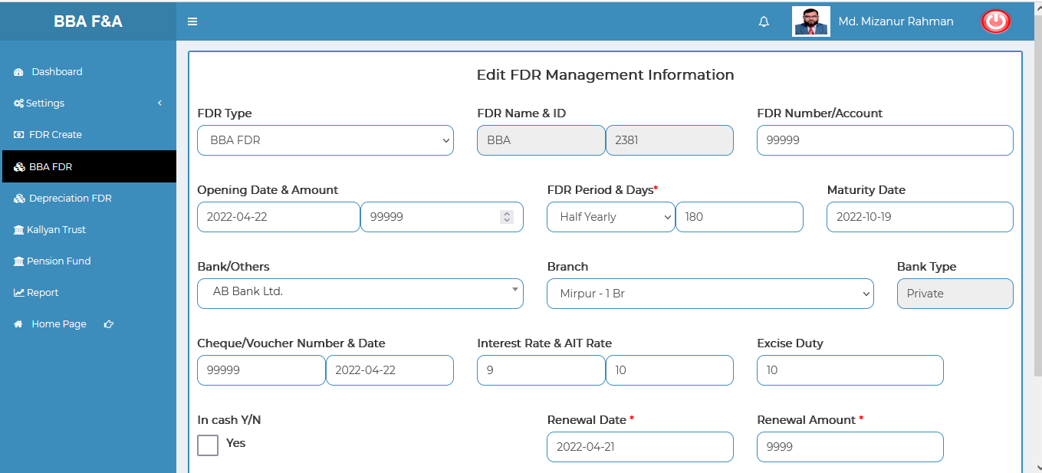

Figure 8.3.1.3: (BBA FDR) update input form

### 8.3.1.4: (BBA FDR) Search

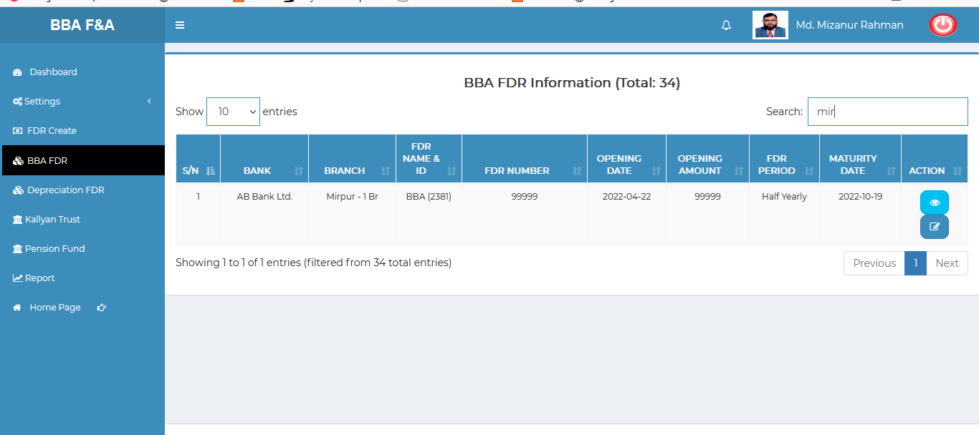

Figure 8.3.1.4: (BBa FDR) search

## 8.4: Depreciation FDR Menu Overview

**Overview of Depreciation FDR**

### 8.4.1.1: (Depreciation FDR) View of Depreciation FDR Information

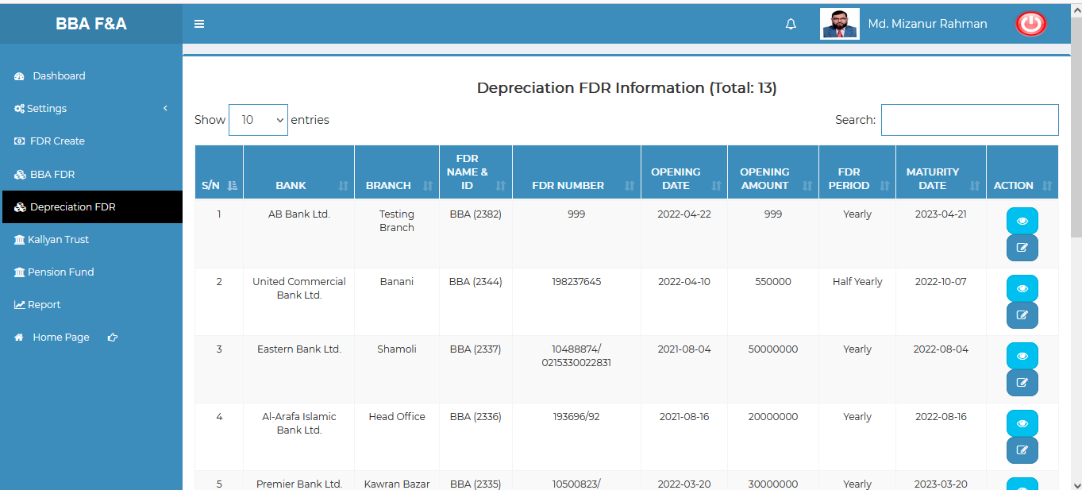

Figure 8.4.1.1: (depreciation FDR) view of depreciation fdr information

### 8.4.1.2: (Depreciation FDR) View of Single Details

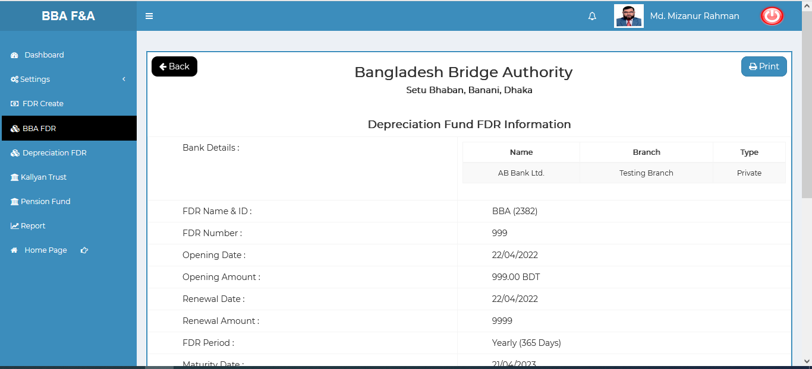

Figure 8.4.1.2: (depreciation FDR) view of depreciation single details

### 8.4.1.3: (Depreciation FDR) Update input form

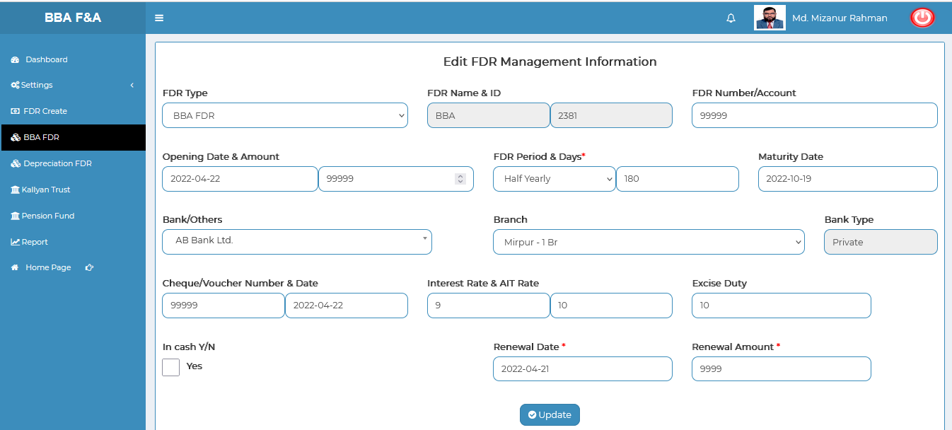

Figure 8.4.1.3: (depreciation FDR) update input form

### 8.4.1.4: (Depreciation FDR) Search

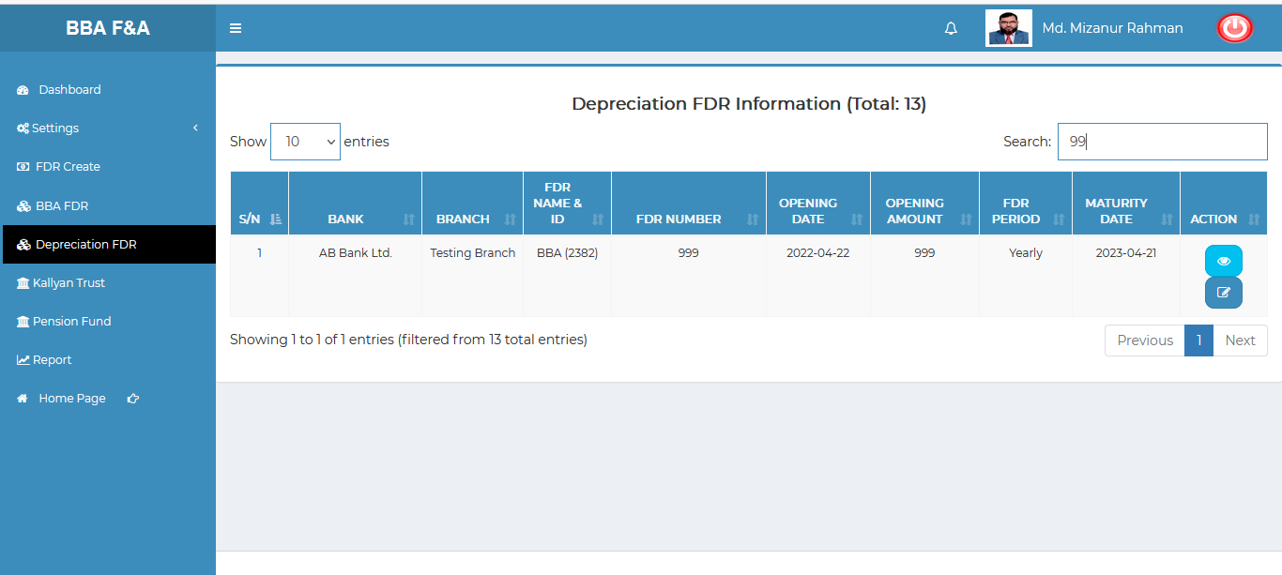

Figure 8.4.1.4: (depreciation FDR) search

## 8.5: Kallyan Trust Menu Overview (Not working ,under processing……)

## 8.6: Pension Fund Menu Overview (Not working ,under processing……)

## 8.7: Report Menu Overview

**Overview of Report**

### 8.7.1.1: (Report) FDR Report generator input field

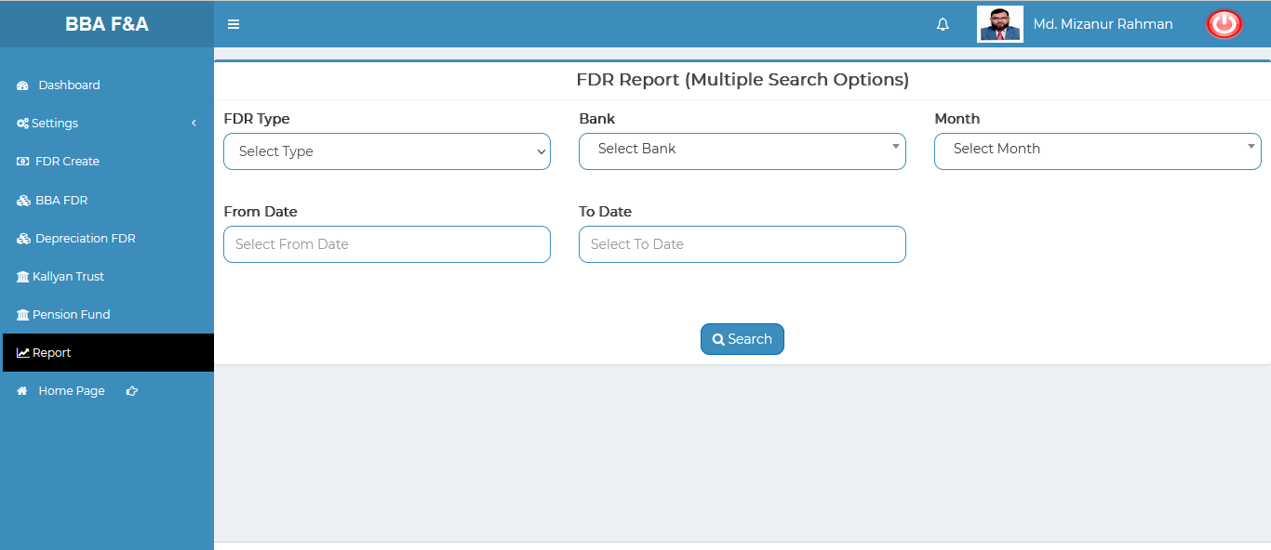

Figure 8.7.1.1: (Report) fdr report generator input field